**Acknowledgement**

I take this opportunity to thank my guides for their expert guidance and mentoring and continuous encouragement throughout to see that this project right’s its target since its commencement to its completion.

I am also grateful to **Dr. Fr. Victor Lobo J**, Principal, St. Joseph’s College (Autonomous) for his blessings and support.

I am also grateful to my teachers from the **Department of Computer Science** who helped me directly or indirectly during the course of this work, and also to my friends and family for analysing and praising my work and help me bring out the best.

**Index**

1. Introduction……………….……….……………….05
2. Study of Existing System……….………………......06
3. Study of Proposed System …………….…………...07
4. System Requirements………………………………08
5. Website navigation flow Chart ……………….……09
6. Code and screenshots
   1. Welcome Page……………………………… 09
   2. Home Page……………………………………13
   3. Album Page…………………………………..33
   4. Playlist Page………………………………….44
   5. Artists Page…………………………………..55
   6. Genre page…………………………………...78
7. Future Enhancement……… ………...…………….87
8. Conclusion………………………………………....87
9. Bibliography……………………………………….88

**ABSTRACT**

The objective of this project is to design a music web application with a comprehensible user interface to enable them to get songs that they like. The motivation of this project comes from our desire to learn the increasingly growing field of HTML5, CSS, JS website designing, and their growing popularity by taking up this case study.

The word “design” in the context of a Web Application can mean many things. Its most popular usage probably refers to the visual and user interface design of a web site. This aspect is crucial because, the visitor is often more impressed with how a website looks and how easy it is to use than about what technologies and techniques are used behind the scenes, or what operating system the webserver is running. If the site is hard to use and easy to forget, it just doesn’t matter what technologies were used to create it. Unfortunately, this truth makes many inexperienced programmers underestimate the importance of the way the invisible part of the site is implemented—the code, and so on. The visual part of a site gets visitors interested, to begin with, but its functionality makes them come back. A web site can sometimes be implemented very quickly based on certain initial requirements, but if not properly architected, it can become difficult, if not impossible, to change. Thus, performance is also a major thrust area in the Web application which is one of the main reasons why users get attracted to it. Growing user needs should be taken into concern with new features to be included. Effective performance can be achieved by making a proper code strategy. Also, easy navigation needs to be accomplished while executing this project.

**Introduction**

**1.Purpose and Motivation**

Our primary reason to assemble a web application (regularly called as a website) for music is to give a decent easy to use music site for free of cost. In the current framework they give top notch music in a wide verity of music's regard to the dialects, region, etc., yet consequently they request that the user buy in prime to overcome issue we have thought of our new site where anyone can get to openly from any place from globe. The motivation of this project comes from our desire to learn the increasingly growing field of Html5, CSS, JS website designing and their growing popularity

**2.Project overview**

The project title is known as “**RHYTHM**’. Our main aim is to bring up a well developed user friendly music web application .and the overall architecture of our website is easily understandable by an external user without any user manual or any instructor, Which makes the users feel comfortable and use the website effortlessly. The user gets to use and enjoy the good quality music without much thought and effort.

**3.Project Category:**

Category of our project is based on web application.

**A. Study of Existing System**

* Unlike others music website it is free of cost.
* Being reasonably-priced is not the only motive that even top stages producers are searching out royalty loose track there are numerous websites which have large collection of high exceptional music production tune to pick from.
* great quality music for less internet data (**Wi-Fi**) absorption.
* In existing music websites for high quality music Users needs to buy in for premium records.

**B. Study of Proposed system**

* Accessibility is way too easy in compare to other websites.
* It is the easiest and most affordable way.
* User don’t have to direct to pages for each song.
* Our music website provides the free music accessing.
* It also provides free download options.

**FRONTEND**

**HTML,CSS and JS**

**C. System Requirements**

* **Hardware (Recommended)**
* Intel Pentium or any above processor
* RAM-512MB

Ethernet connection (LAN) or a wireless adapter (Wi- Fi)

* **Software (Recommended)**

Operating System – Windows 7 and above

**4. Website Navigation flow chart**

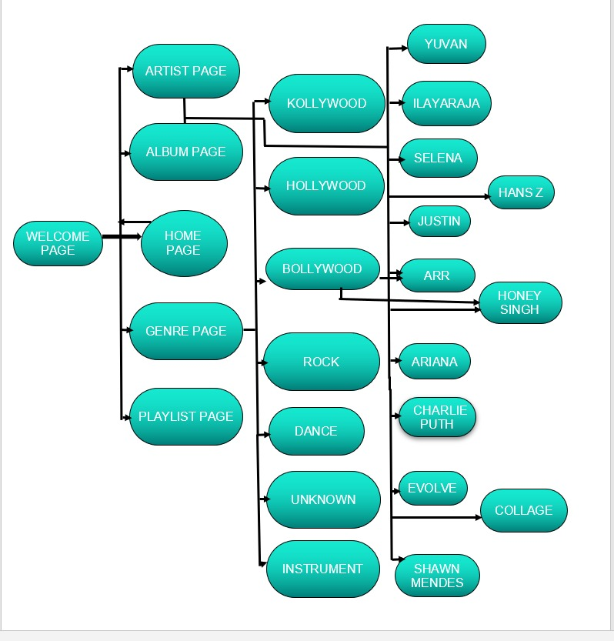

Caption

1. **Welcome Page**

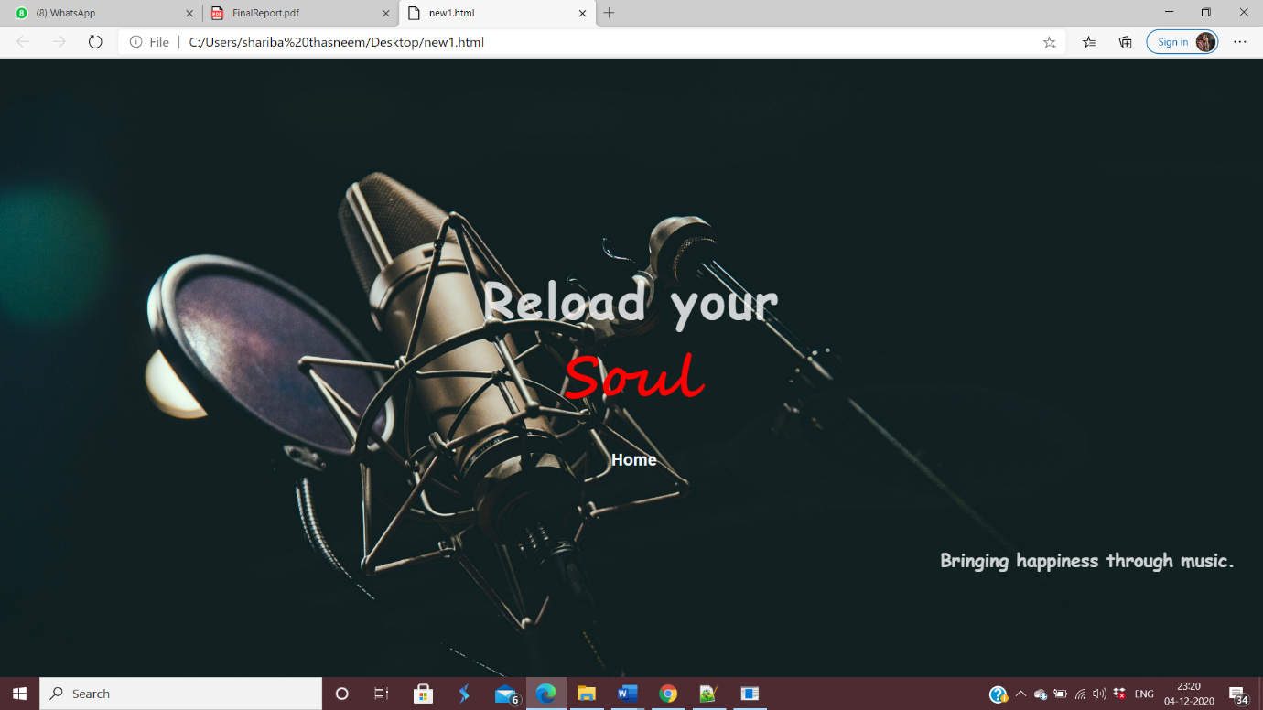

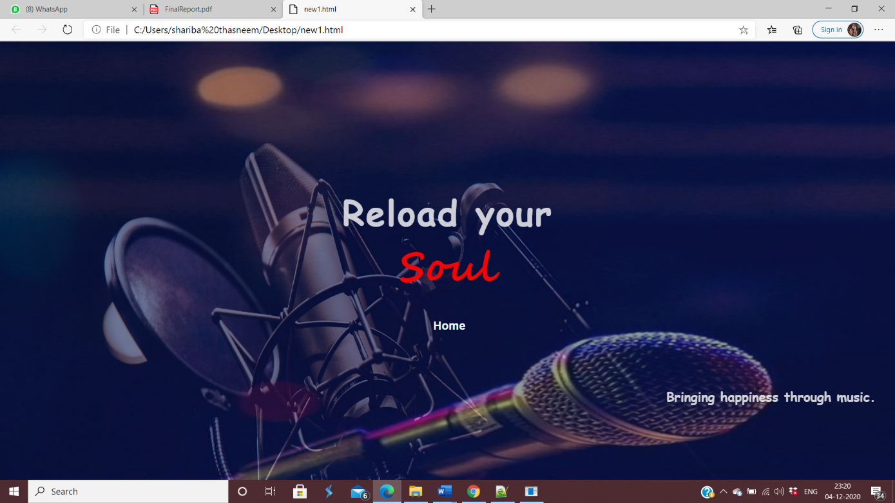

**CODE**

<!DOCTYPE html>

<html lang="en" dir="ltr">

<head>

<meta charset="utf-8">

<meta name="viewport" content="width=device-width, initial-scale=1.0">

<link rel="stylesheet" href="style.css">

<script src="https://kit.fontawesome.com/a076d05399.js"></script>

<style type="text/css">

*{

padding: 0;

margin: 0;

text-decoration: none;

list-style: none;

box-sizing: border-box;

}

body{

background-image: url(https://i.pinimg.com/564x/1e/42/31/1e42312e68f05f69da2379a9148f9892.jpg);

width: 100%;

height: 100%;

overflow: hidden;

position: relative;

background-size: cover;

background-repeat: no-repeat;

animation: slide 12s infinite;}

@keyframes slide {

20% { background-image: url(https://wallpapercrafter.com/desktop/273905-microphone-music-dark-and-mic-hd.jpg);

}

40% { background-image: url(https://images.pexels.com/photos/811838/pexels-photo-811838.jpeg?auto=compress&cs=tinysrgb&dpr=2&h=650&w=940);

}

60% { background-image: url(https://images.unsplash.com/photo-1518972559570-7cc1309f3229?ixlib=rb-1.2.1&ixid=eyJhcHBfaWQiOjEyMDd9&auto=format&fit=crop&w=1050&q=80);

}

80% { background-image: url(https://www.teahub.io/photos/full/1-11715_3840x2160-wallpaper-from-music-category-studio-music.jpg);

}

100% { background-image: url(https://free4kwallpapers.com/uploads/originals/2020/05/09/dj-headphones-by-mikael-kristenson-wallpaper.jpg) }

}

div h2 {

color: rgba(255, 255, 255, 0.795);

font-family: Comic Sans MS;

text-align: center;

margin-top: 120px;

font-size: 60px;

letter-spacing: 2px;

background-blend-mode: multiply;

}

div form input {

margin-left: 45%;

margin-top: 20px;

width: 160px;

height: 45px;

border-radius: 30px;

padding: 10px 8px;

font-size: 20px;

font-weight: bolder;

background-color: transparent;

border: 1px silver;

color: aliceblue;

margin-bottom: 20px;

}

div form input:hover {

background-color: grey;

color: black;

}

div h1{

text-align: center;

font-size: 70px;

font-family: Segoe Script;

}

div h3 {

font-size: 22px;

padding: 3px;

text-align: right;

background-color: transparent;

color: white;

font-family: Comic Sans MS;

opacity: 0.8;

margin-right: 2%;

margin-top: 60px;

}

.pos{

margin-top: 250px;

}

</style>

</head>

<body>

<div>

<div class="pos">

<h2><b>Reload your</b><h1><font color="red">Soul</font></h1></h2>

<form action="Homefinal.html">

<input type="submit" value="Home">

</form>

</div>

<h3>Bringing happiness through music.</h3>

</div>

</body>

</html>

**b.Home page**

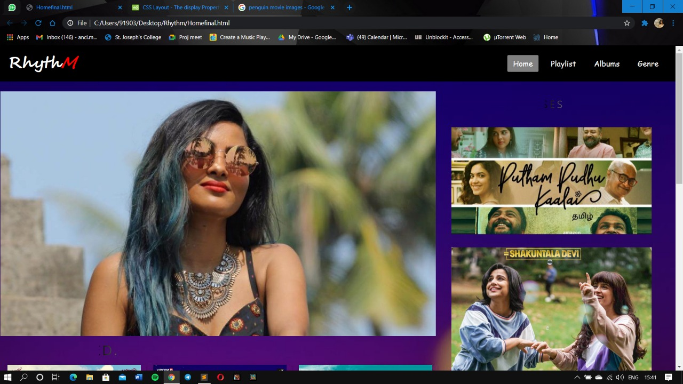

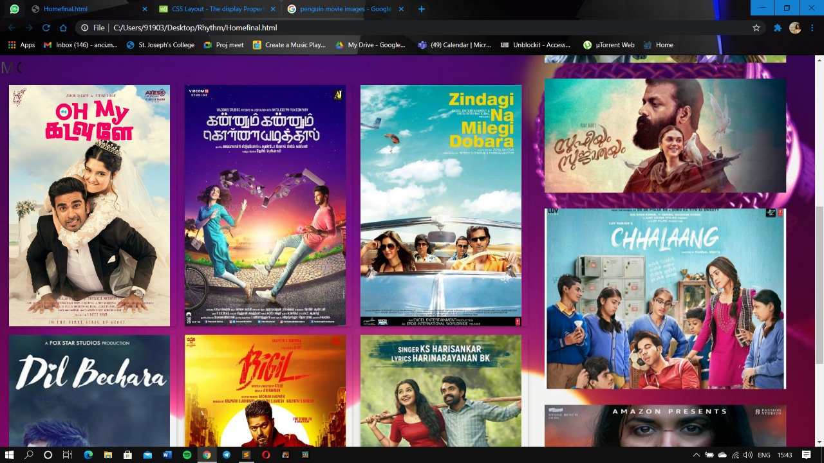

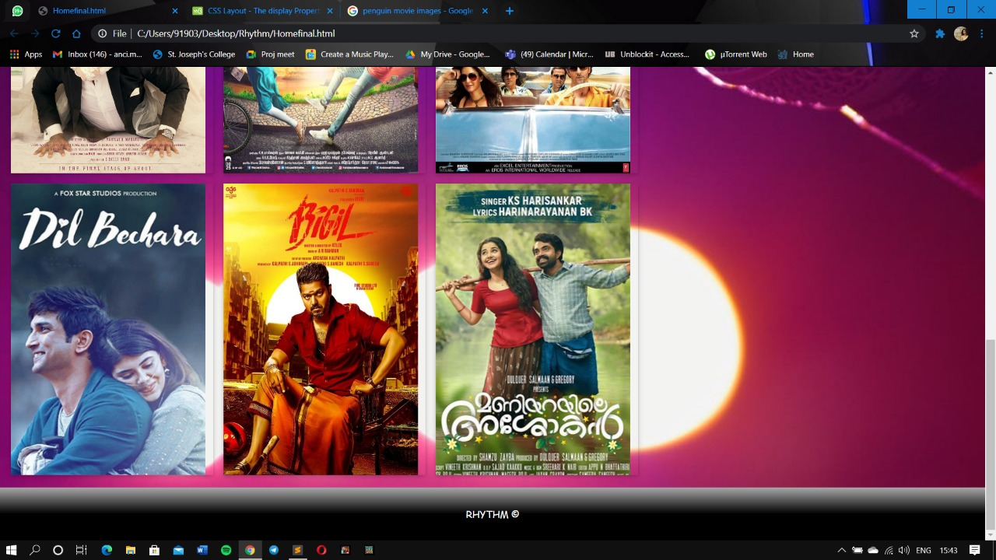

**CODE**

<!DOCTYPE html>

<html lang="en" dir="ltr">

<head>

<meta charset="utf-8">

<meta name="viewport" content="width=device-width, initial-scale=1.0">

<link rel="stylesheet" href="https://cdnjs.cloudflare.com/ajax/libs/font-awesome/4.7.0/css/font-awesome.min.css">

<link rel="stylesheet" href="style.css">

<link rel="stylesheet" href="https://www.w3schools.com/w3css/4/w3.css">

<script src="https://kit.fontawesome.com/a076d05399.js"></script></head>

<style type="text/css">

*{

padding: 0;

margin: 0;

text-decoration: none;

list-style: none;

box-sizing: border-box;

}

body{

font-family: Comic Sans MS;

background-image: url(https://images.pexels.com/photos/144429/pexels-photo-144429.jpeg?auto=compress&cs=tinysrgb&dpr=2&h=650&w=940);

background-repeat: no-repeat;

background-size: cover;

}

nav{

background: black;

height: 80px;

width: 100%;}

label.logo{

font-family: Segoe Script;

font-size: 35px;

line-height: 80px;

padding: 0 100px;

font-weight: bold;

padding-left: 1px;

}

nav ul{

float: right;

margin-right: 20px;

}

nav ul li{

display: inline-block;

line-height: 80px;

margin: 0 5px;

}

nav ul li a{

color: white;

font-size: 17px;

padding: 7px 13px;

border-radius: 3px;

}

.active{

background-color: grey;

}

a:hover{

background: transparent ;

font-size: 20px;

transition: .5s;

color: solid white;

}

.checkbtn{

font-size: 30px;

color: white;

float: right;

line-height: 80px;

margin-right: 40px;

cursor: pointer;

display: none;

}

#check{

visibility: hidden;

}

@media (max-width: 952px){

label.logo{

font-size: 30px;

padding-left: 50px;

}

nav ul li a{

font-size: 16px;

}

}

@media (max-width: 858px){

.checkbtn{

display: block;

}

ul{

position: fixed;

width: 100%;

height: 100vh;

background: orange;

top: 80px;

left: -100%;

text-align: center;

transition: all .5s;

}

nav ul li{

display: block;

margin: 50px 0;

line-height: 30px;

}

nav ul li a{

font-size: 20px;

}

a:hover,a.active{

background: none;

color: transparent;

}

#check:checked ~ ul{

left: 0;

}

.mySlides {

visibility: hidden;

}

section{

visibility: none;

}

.flip-box{

visibility: hidden;

display: none;

}

.flip-box-inner {

visibility: hidden;

}

.flip-box-front, .flip-box-back {

visibility: hidden;

}

h2{

visibility: hidden;

}

}

.slideshow-container {

max-width: 1000px;

position: relative;

margin: auto;

float: left;

padding-left: 1px

}

.mySlides {

display: none;

}

@-webkit-keyframes fade {

from {opacity: .2}

to {opacity: 1}

}

h2{

position: relative;

font-family: sans-serif;

text-transform: uppercase;

font-size: 2em;

letter-spacing: 4px;

overflow: hidden;

background: linear-gradient(90deg, #000, #fff, #000);

background-repeat: no-repeat;

background-size: 80%;

animation: animate 3s linear infinite;

-webkit-background-clip: text;

-webkit-text-fill-color: rgba(255, 255, 255, 0);

float: left;

}

.fade {

-webkit-animation-name: fade;

-webkit-animation-duration: 1.5s;

animation-name: fade;

animation-duration: 1.5s;

}

p.pright{

color:white;

font-size: 20px;

display: inline-block;

}

p.flip-box-front, .flip-box-back {

position: absolute;

width: 200%;

height: 100%;

-webkit-backface-visibility: hidden;

backface-visibility: hidden;

}

.flip-box-front {

background-color:transparent;

color: black;

}

.flip-box-back {

background-color: #111;

opacity: 0.7;

text-align: center;

align-items: center;

color: transparent;

transform: rotateY(180deg);

}

section{

text-align:left ;

width:500px;

align-items: right;

height: auto;

float:right;

margin-right:4px;

font-family: Calibri;

}

.flip-box {

background-color: transparent;

width: 300px;

height: 450px;

border: transparent;

perspective: 1000px;

}

.flip-box-inner {

position: relative;

width: 100%;

height: 100%;

text-align: center;

transition: transform 0.8s;

transform-style: preserve-3d;

}

.flip-box:hover .flip-box-inner {

transform: rotateY(180deg);

}

.flip-box-front, .flip-box-back {

position: absolute;

width: 100%;

height: 100%;

-webkit-backface-visibility: hidden;

backface-visibility: hidden;

}

.flip-box-front {

background-color:transparent;

color: black;

}

.flip-box-back {

background-color: #111;

opacity: 0.7;

text-align: center;

align-items: center;

color: transparent;

transform: rotateY(180deg);

}

.Recent{

position: relative;

font-family: sans-serif;

text-transform: uppercase;

font-size: 2em;

letter-spacing: 4px;

overflow: hidden;

background: linear-gradient(90deg, #000, #fff, #000);

background-repeat: no-repeat;

background-size: 80%;

animation: animate 3s linear infinite;

-webkit-background-clip: text;

-webkit-text-fill-color: rgba(255, 255, 255, 0);

float: left;

}

.fade {

-webkit-animation-name: fade;

-webkit-animation-duration: 1.5s;

animation-name: fade;

animation-duration: 1.5s;

}

}

h3{

color: white;

}

.footer {

left: 0;

margin-top: 1550px;

width: 100%;

background: linear-gradient(to bottom, darkgrey 0%, black 50%);

color: white;

text-align: center;

position: bottom;

padding: 30px;

}

button{

border-radius: 30%;

padding-left: 10px;

padding-right: 10px;

padding-top: 10px;

padding-bottom: 10px;

background-color: transparent;

color: yellow;

border-color: orange;

}

@keyframes animate {

0% {

background-position: -500%;

}

100% {

background-position: 500%;

}

@-webkit-keyframes fade {

from {opacity: .4}

to {opacity: 1}

}

@keyframes fade {

from {opacity: .4}

to {opacity: 1}

}

</style>

</head>

<body>

<nav>

<input type="checkbox" id="check">

<label for="check" class="checkbtn">

<i class="fas fa-bars"></i>

</label>

<label class="logo"><font color="white">Rhyth</font><i><font color= "red">M</font></i></label>

<ul>

<li><a class="active" href="home1.html">Home</a></li>

<li><a href="#">Playlist</a></li>

<li><a href="Album2.html">Albums</a></li>

<li><a href="genrepg.html">Genre</a></li>

</ul>

</nav>

<br>

<section>

<div class="Recent">

<h3>Recent Releases</h3></div>

<marquee direction="up">

<p class="pright">

<img src="https://www.pinkvilla.com/files/styles/fbimagesection/public/s_karthik_subbarajs_story_from_putham_pudhu_kaalai.jpg?itok=IIRoXRYo" style="width: 90%" "margin-bottom: 30px;">

<br>

<br>

<img src="https://static-koimoi.akamaized.net/wp-content/new-galleries/2020/07/shakuntala-devi-movie-review-2.jpg" style="width: 90%;" >

<br><br>

<img src="https://www.nowrunning.com/content/movie/2020/sufiy-24545/bg_sufi.jpg" style="width: 90%;" >

<br><br>

<img src="https://www.pinkvilla.com/files/styles/amp_metadata_content_image/public/chhalaang_first_poster_rajkummar_rao_and_nushrat_bharucha_starrer_gets_a_new_release_date.jpg" style="width: 90%;" >

<br><br>

<img src="https://thandoratimes.com/flcimgs/review/penguin-movie-review.jpg?ts=1604333156" style="width: 90%;">

</p>

</marquee></section>

<div class="slideshow-container">

<!-- Full-width images with number and caption text -->

<div class="mySlides fade">

<!--<div class="numbertext">1 / 3</div>-->

<img src="https://www.wallpapertip.com/wmimgs/71-719253_hd-ed-sheeran-wallpapers-01-hd-ed-sheeran.jpg" style="width:98%">

</div>

<div class="mySlides fade">

<img src="https://www.xtrafondos.com/en/descargar.php?id=3795&resolucion=3840x2160.jpg" style="width:98%">

</div>

<div class="mySlides fade">

<img src="https://i.pinimg.com/originals/94/98/12/949812f6e825b3ad2005f4608642f746.jpg" style="width:98%; ">

</div>

<div class="mySlides fade">

<img src="https://images.alphacoders.com/101/1012617.jpg" style="width:98%">

</div>

<div class="mySlides fade">

<img src="https://www.newsbugz.com/wp-content/uploads/2018/04/Vidya-Vox-Images-8-1280x720.jpg" style="width:98%">

</div>

<h2 style="text-align:center">MOST PLAYED.</h2>

<div class="w3-row-padding w3-margin-top">

<div class="w3-third">

<div class="w3-card">

<div class="flip-box">

<div class="flip-box-inner">

<div class="flip-box-front">

<img src="https://m.media-amazon.com/images/M/MV5BMzRiZGZmYWMtMmNhYy00NmE3LTgxZjItMDc1YzMxNTExM2VlXkEyXkFqcGdeQXVyMTEwNjA3NjE1._V1_.jpg" style="width:100%;height: 100%">

</div>

<div class="flip-box-back">

<p><br><br><h3>Oh My Kadavule</h3></p>

<form action="get/page2">

<button type="submit">Click to listen</button>

</form>

<div class="w3-container">

</div>

</div>

</div>

</div>

</div>

</div>

<div class="w3-third">

<div class="w3-card">

<div class="flip-box">

<div class="flip-box-inner">

<div class="flip-box-front">

<img src="https://i.pinimg.com/736x/10/62/5c/10625cee9cfce6268f8bba8906be1683.jpg" style="width:100%; height: 100%"></div>

<div class="flip-box-back">

<p><br> <br><h3>Kannum Kannum Kollaiyadithaal</h3></p>

<p><button>Click to Listen</button></p>

<div class="w3-container">

</div>

</div>

</div>

</div>

</div>

</div>

<div class="w3-third">

<div class="w3-card">

<div class="flip-box">

<div class="flip-box-inner">

<div class="flip-box-front">

<img src="https://bestoftheyear.in/wp-content/uploads/2016/03/zindagi-na-milegi-dobara.jpg" style="width:100%;height: 100%">

</div>

<div class="flip-box-back">

<p><h3><br> <br>Zindagi Na Milegi Dobaara</h3></p>

<p><button>Click to Listen</button></p>

<div class="flip-box-back">

</div>

</div>

</div>

</div>

</div>

</div>

</div>

<div class="w3-row-padding w3-margin-top">

<div class="w3-third">

<div class="w3-card">

<div class="flip-box">

<div class="flip-box-inner">

<div class="flip-box-front">

<img src="https://www.binged.com/wp-content/uploads/2020/07/Dil-Bechara-Binged-com.jpg" style="width:100%; height: 100%">

</div>

<div class="flip-box-back">

<p> <h3><br><br> Dil Bechara</h3></p>

<p><button>Click to Listen</button></p>

<div class="w3-container">

</div>

</div>

</div>

</div>

</div>

</div>

<div class="w3-third">

<div class="w3-card">

<div class="flip-box">

<div class="flip-box-inner">

<div class="flip-box-front">

<img src="https://www.99images.com/photos/movies-tv/bigil/bigil-movie-latest-hd-photos-posters-wallpapers-download-1080p-50bg.jpg?v=1577308442" style="width:100%; height: 100%">

</div>

<div class="flip-box-back">

<p><h3><br><br> Bigil</h3></p>

<p><button>Click to Listen</button></p>

<div class="w3-container">

</div>

</div>

</div>

</div>

</div>

</div>

<div class="w3-third">

<div class="w3-card">

<div class="flip-box">

<div class="flip-box-inner">

<div class="flip-box-front">

<img src="https://www.binged.com/wp-content/uploads/2020/08/Maniyarayile-Ashokan.jpg" style="width:100%;height: 100%">

</div>

<div class="flip-box-back">

<p><h3><br> <br>Maniyarayile Ashokan</h3></p>

<p><button>Click to Listen</button></p>

<div class="w3-container">

</div>

</div>

</div>

</div>

</div>

</div>

</div>

</div>

</body>

<div class="footer">

<h5class="monospace">RHYTHM &#169;</h5>

</div>

<script type="text/javascript">

var slideIndex = 0;

showSlides();

function showSlides() {

var i;

var slides = document.getElementsByClassName("mySlides");

for (i = 0; i < slides.length; i++) {

slides[i].style.display = "none";

}

slideIndex++;

if (slideIndex > slides.length) {slideIndex = 1}

slides[slideIndex-1].style.display = "block";

setTimeout(showSlides, 2000); // Change image every 2 seconds

}

</script>

</html>

**C**.**ALBUM PAGE**

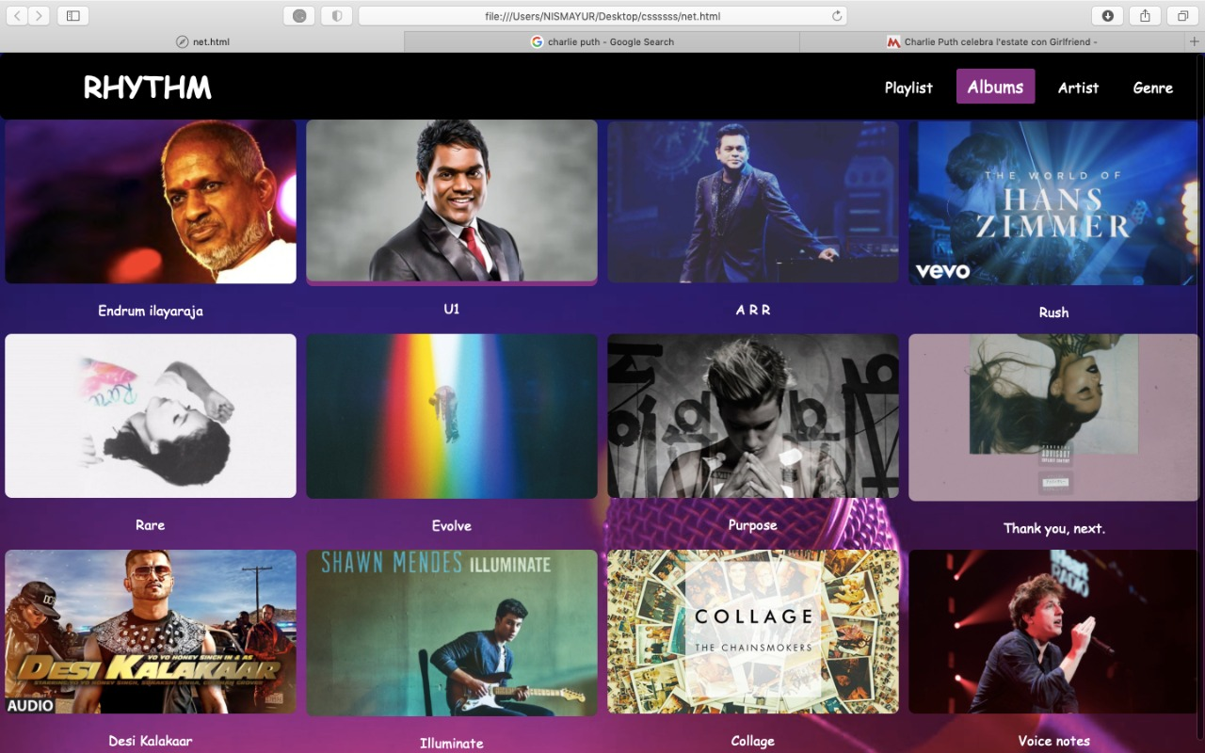

**CODE**

<!DOCTYPE html>

<html>

<head>

<meta name="viewport" content="width=device-width, initial-scale=1.0">

<link rel="stylesheet" href="style.css">

<script src="https://kit.fontawesome.com/a076d05399.js"></script>

<style type="text/css">

*{

padding: 0;

margin: 0;

text-decoration: none;

list-style: none;

box-sizing: border-box;

}

body{

font-family: Comic Sans MS;

background-image:url(https://images.pexels.com/photos/144429/pexels-photo-144429.jpeg?auto=compress&cs=tinysrgb&dpr=2&h=650&w=940);

}

nav{

background: black;

height: 80px;

width: 100%;

}

label.logo{

color: white;

font-size: 35px;

line-height: 80px;

padding: 0 100px;

font-weight: bold;

}

nav ul{

float: right;

margin-right: 20px;

}

nav ul li{

display: inline-block;

line-height: 80px;

margin: 0 5px;

}

nav ul li a{

color: white;

font-size: 17px;

padding: 7px 13px;

border-radius: 3px;

}

a.active,a:hover{

background: purple ;

font-size: 20px;

transition: .5s;

color: solid white;

}

.checkbtn{

font-size: 30px;

color: white;

float: right;

line-height: 80px;

margin-right: 40px;

cursor: pointer;

display: none;

}

#check{

display: none;

}

@media (max-width: 952px){

label.logo{

font-size: 30px;

padding-left: 50px;

}

nav ul li a{

font-size: 16px;

}

}

@media (max-width: 858px){

.checkbtn{

display: block;

}

ul{

position: fixed;

width: 100%;

height: 100vh;

background: orange;

top: 80px;

left: -100%;

text-align: center;

transition: all .5s;

}

nav ul li{

display: block;

margin: 50px 0;

line-height: 30px;

}

nav ul li a{

font-size: 20px;

}

a:hover,a.active{

background: none;

color: transparent;

}

#check:checked ~ ul{

left: 0;

}

}

</style>

</head>

<body>

<nav>

<input type="checkbox" id="check">

<label for="check" class="checkbtn">

<i class="fas fa-bars"></i>

</label>

<label class="logo">RHYTHM</label>

<ul>

<li><a href="#">Playlist</a></li>

<li><a class ="active" href="#">Albums</a></li>

<li><a href="#">Artist</a></li>

<li><a href="#">Genre</a></li>

</ul>

</nav>

</body>

</html>

<style>

div.gallery {

border: 1px transparent;

}

div.gallery:hover {

border: 1px transparent;

}

div.gallery img {

width: 100%;

height: 100%;

}

div.desc {

padding: 15px;

text-align: center;

color: white;

}

div.image:hover{

transform: scaleX(-1);

}

* {

box-sizing: border-box;

border-radius: 8px;

}

.responsive {

padding: 0 6px;

float: left;

width: 24.99999%;

}

h2

{

text-align: center;

background-color: rgba(0 2 5 66);

}

@media only screen and (max-width: 800px) {

.responsive {

width: 49.99999%;

margin: 6px 0;

}

}

@media only screen and (max-width: 800px) {

.responsive {

width: 100%;

}

}

.clearfix:after {

content: "";

display: table;

clear: both;

}

</style>

</head>

<body>

<div class="responsive">

<div class="gallery">

<a target="_blank" href="">

<div class="image">

<img src="https://m.hindustantimes.com/rf/image_size_960x540/HT/p2/2018/03/13/Pictures/concert-maestro-ilayaraja-enthralled-music-lovers-first_49150ca4-2677-11e8-9f95-06a811d7e716.jpg" alt= "ilayaraja" width="800" height="auto">

</a></div>

<div class="desc">Endrum ilayaraja</div>

</div>

</div>

<div class="responsive">

<div class="gallery">

<a target="_blank" href="">

<div class="image">

<img src="https://tamil.stage3.in/root_upld/general-news/2018/01/ART045668436021407/org_71606201801231106.jpg" alt= "yuvan s raja" width="800" height="auto">

</a></div>

<div class="desc">U1</div>

</div>

</div>

<div class="responsive">

<div class="gallery">

<a target="_blank" href="">

<div class="image">

<img src="https://images.indianexpress.com/2019/01/ar-rahman-top-tamil-songs-from-the-90s-1200.jpg" alt= "A R rahman" width="800" height="auto">

</a></div>

<div class="desc">A R R</div>

</div>

</div>

<div class="responsive">

<div class="gallery">

<a target="_blank" href="">

<div class="image">

<img src="https://i.ytimg.com/vi/DwiEDAsWpJs/maxresdefault.jpg" alt= "Hans Zimmer" width="800" height="auto">

</a></div>

<div class="desc">Rush</div>

</div>

</div>

<div class="responsive">

<div class="gallery">

<a target="_blank" href="">

<div class="image">

<img src="https://www.kiss925.com/wp-content/uploads/sites/59/2019/12/selena-gomez-rare-1024x399-e1577046724182-1024x576.jpg" alt="Cinque Terre" width="800"

height="auto" >

</a></div>

<div class="desc">Rare</div>

</div>

</div>

<div class="responsive">

<div class="gallery">

<a target="_blank" href="">

<div class="image">

<img src="https://roundhouse-assets.s3.amazonaws.com/assets/Image/13275-fitandcrop-1200x681.jpg" alt="Mountains" width="800" height="auto">

</a></div>

<div class="desc">Evolve</div>

</div>

</div>

<div class="responsive">

<div class="gallery">

<a target="_blank" href="">

<div class="image">

<img src="https://www.grammy.com/sites/com/files/styles/news_detail_header/public/news/r-7717555-1447497442-7892.jpeg.jpg?itok=zq_E8MV0" alt="justin" width="800" height="auto">

</a></div>

<div class="desc">Purpose</div>

</div>

</div>

<div class="responsive">

<div class="gallery">

<a target="_blank" href="">

<div class="image">

<img src="https://www.pluggedin.com/wp-content/uploads/2020/01/Ariana__Thank_You_Next__Large.jpg" alt="ariana" width="800" height="auto">

</a></div>

<div class="desc">Thank you, next.</div>

</div>

</div>

<div class="responsive">

<div class="gallery">

<a target="_blank" href="">

<div class="image">

<img src="https://i.ytimg.com/vi/6Iovt3Pe0S4/maxresdefault.jpg" alt= "honey singh" width="800" height="auto">

</a></div>

<div class="desc">Desi Kalakaar</div>

</div>

</div>

<div class="responsive">

<div class="gallery">

<a target="_blank" href="">

<div class="image">

<img src="https://www.pluggedin.com/wp-content/uploads/2020/01/Shawn_Mendes__Illuminate__Large.jpg-1024x587.jpeg" alt="sm" width="800" height="auto">

</a></div>

<div class="desc">Illuminate</div>

</div>

</div>

<div class="responsive">

<div class="gallery">

<a target="_blank" href="">

<div class="image">

<img src="https://music.mxdwn.com/wp-content/uploads/2016/12/collage-e1481165261413-1280x720.jpg" alt=" collage" width="800" height="auto">

</a></div>

<div class="desc">Collage</div>

</div>

</div>

<div class="responsive">

<div class="gallery">

<a target="_blank" href="">

<div class="image">

<img src="https://rdcnewscdn.realtor.com/wp-content/uploads/2017/12/Charlie-Puth-1024x576.jpg" alt="charlie puth" width="1300" height="auto">

</a></div>

<div class="desc">Voice notes</div>

</div>

</div>

<div class="clearfix"></div>

</body>

</html>

**d. PLAYLIST**

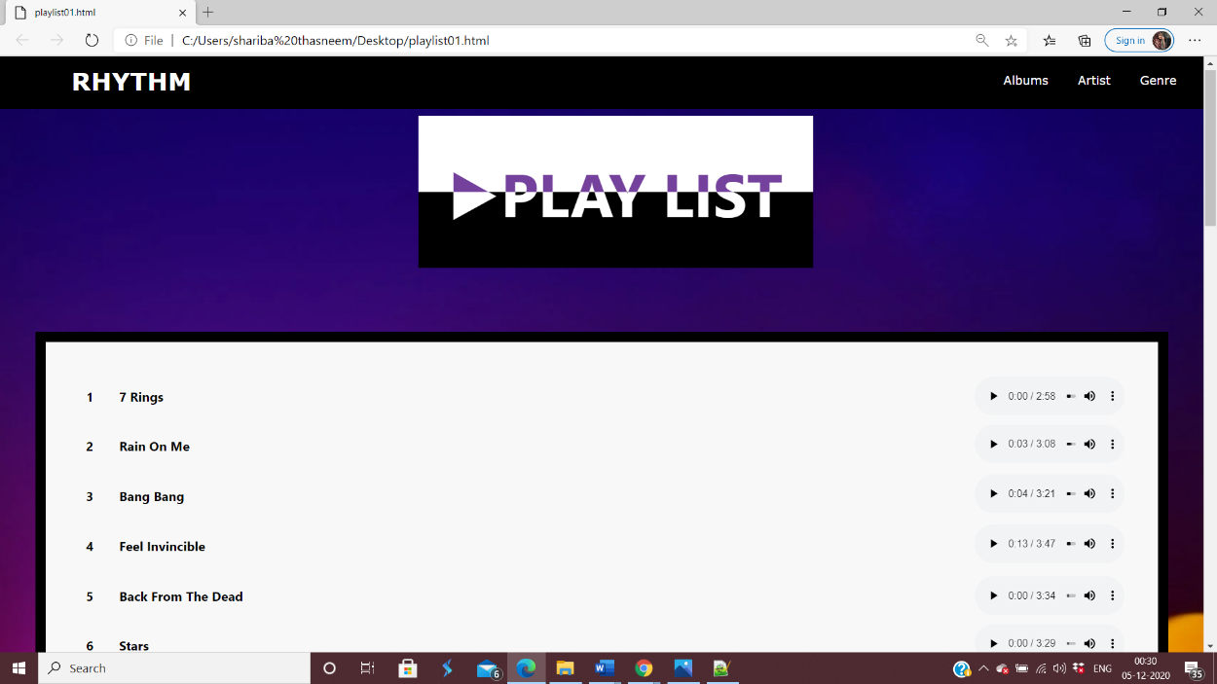

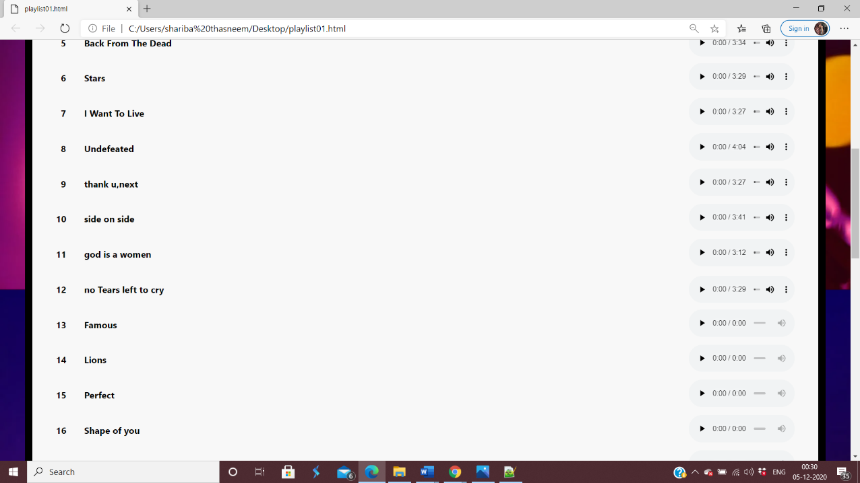

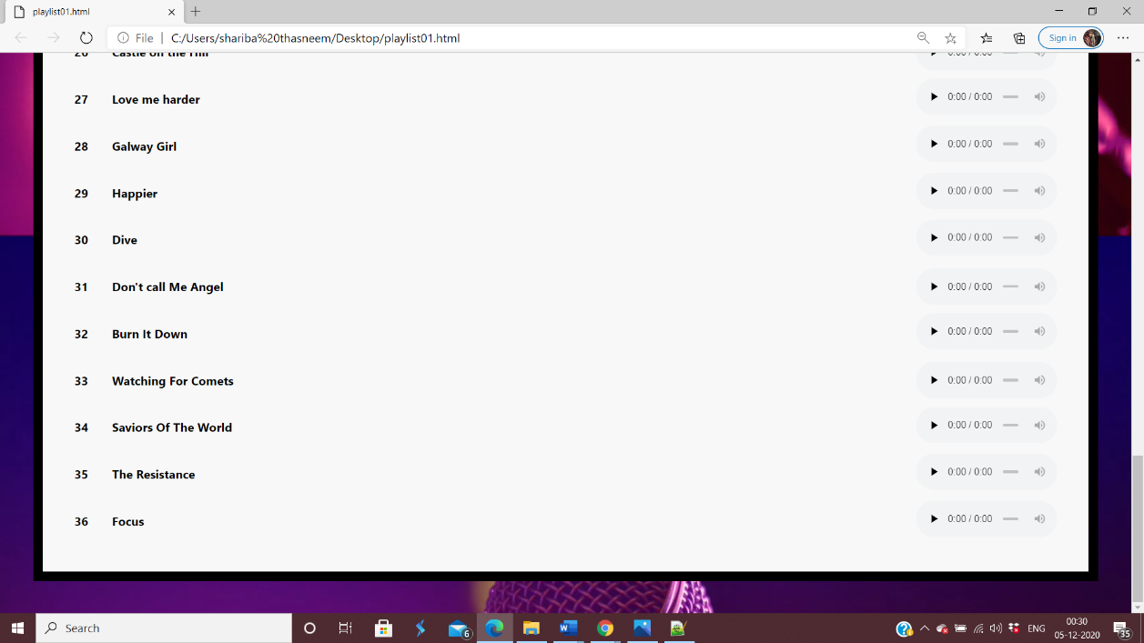

|  |  |
| --- | --- |
|  |  |
|  | **CODE**  <!DOCTYPE html>  <html> |
|  | <head> |
|  | <link rel="stylesheet" href="<https://www.w3schools.com/w3css/4/w3.css>"> |
|  | <meta charset="utf-8"> |
|  | <meta name="viewport" content="width=device-width, initial-scale=1.0"> |
|  | <link rel="stylesheet" href="style.css"> |
|  | <script src="<https://kit.fontawesome.com/a076d05399.js>"></script> |
|  | <style type="text/css"> |
|  |  |
|  | *{ |
|  | padding: 0; |
|  | margin: 0; |
|  | text-decoration: none; |
|  | list-style: none; |
|  | box-sizing: border-box; |
|  | } |
|  | .container{ |
|  | margin: auto; |
|  | position: relative; |
|  | left: 0; |
|  | right:0; |
|  |  |
|  | } |
|  | .audio { width: 210px; } |
|  | nav{ |
|  | background: black; |
|  | height: 80px; |
|  | width: 100%; |
|  | } |
|  | label.logo{ |
|  | color: white; |
|  | font-size: 35px; |
|  | line-height: 80px; |
|  | padding: 0 100px; |
|  | font-weight: bold; |
|  | } |
|  | nav ul{ |
|  | float: right; |
|  | margin-right: 20px; |
|  | } |
|  | nav ul li{ |
|  | display: inline-block; |
|  | line-height: 80px; |
|  | margin: 0 5px; |
|  | } |
|  | nav ul li a{ |
|  | color: white; |
|  | font-size: 17px; |
|  | padding: 7px 13px; |
|  | border-radius: 3px; |
|  |  |
|  | } |
|  | a.active,a:hover{ |
|  | background: transparent ; |
|  | font-size: 20px; |
|  | transition: .5s; |
|  | color: solid white; |
|  | } |
|  | .checkbtn{ |
|  | font-size: 30px; |
|  | color: white; |
|  | float: right; |
|  | line-height: 80px; |
|  | margin-right: 40px; |
|  | cursor: pointer; |
|  | display: none; |
|  | } |
|  | #check{ |
|  | display: none; |
|  | } |
|  |  |
|  | @media (max-width: 858px){ |
|  | .checkbtn{ |
|  | display: block; |
|  | } |
|  | ul{ |
|  | position: fixed; |
|  | width: 100%; |
|  | height: 100vh; |
|  | background: orange; |
|  | top: 80px; |
|  | left: -100%; |
|  | text-align: center; |
|  | transition: all .5s; |
|  | } |
|  | nav ul li{ |
|  | display: block; |
|  | margin: 50px 0; |
|  | line-height: 30px; |
|  | } |
|  | nav ul li a{ |
|  | font-size: 20px; |
|  | } |
|  | a:hover,a.active{ |
|  | background: none; |
|  | color: transparent; |
|  | } |
|  | #check:checked ~ ul{ |
|  | left: 0; |
|  | } |
|  | } |
|  |  |
|  | </head> |
|  | <style> |
|  | @import url("https://fonts.googleapis.com/css?family=Roboto:300,400,500,700"); |
|  |  |
|  | :root { |
|  | --color: #ffa700; |
|  | --color-light: #f5ede1; |
|  | --dark: #a6a6a6; |
|  | --sans-serif: 'weight', sans-serif; |
|  |  |
|  | } |
|  |  |
|  |  |
|  | body { |
|  | background-image: url('https://images.pexels.com/photos/144429/pexels-photo-144429.jpeg?auto=compress&cs=tinysrgb&dpr=2&h=650&w=940'); |
|  | } |
|  |  |
|  | @keyframes pulsate1 { |
|  | 0% { |
|  | -webkit-transform: scale(0.4); |
|  | opacity: 1; |
|  | } |
|  | } |
|  | section .album-tracks { |
|  | border: 15px solid #000000; |
|  | margin: 50px 50px; |
|  | padding: 10px 10px; |
|  | color: var(--darker); |
|  | } |
|  | *, |
|  | *:after, |
|  | *:before { |
|  | box-sizing: border-box; |
|  | } |
|  |  |
|  |  |
|  |  |
|  | .text-box { |
|  | position: relative; |
|  | display: flex; |
|  | align-items: center; |
|  | justify-content: center; |
|  | left: 10%; |
|  | margin-left: -100px; |
|  | } |
|  |  |
|  | h1 { |
|  | font-size: 5vw; |
|  | font-weight: 700; |
|  | background-color: #000; |
|  | color: #fff; |
|  | display: block; |
|  | padding: .5em; |
|  | } |
|  |  |
|  | h1:nth-child(2) { |
|  | position: absolute; |
|  | background-color: #fff; |
|  | color: #74419c; |
|  | clip-path: inset(-1% -1% 50% -1%); // Added the negative values to prevent icky "bleed" in Chrome |
|  | } |
|  | section .album-tracks { |
|  | background: #f8f8f8; |
|  | border: 1px solid #fefef; |
|  | margin-top: 80px; |
|  | } |
|  |  |
|  | @media (max-width: 800px) { |
|  | section { |
|  | margin: 100px 36px 36px 36px; |
|  | } |
|  | } |
|  | @media (max-width: 700px) { |
|  | section .album-art { |
|  | width: 100%; |
|  | } |
|  | } |
|  |  |
|  | ol { |
|  | list-style-type: none; |
|  | padding: 20px 36px; |
|  | font-weight: 700; |
|  | } |
|  | ol li { |
|  | counter-increment: number; |
|  | display: -webkit-box; |
|  | display: flex; |
|  | flex-wrap: initial; |
|  | -webkit-box-pack: justify; |
|  | justify-content: space-between; |
|  | -webkit-box-align: center; |
|  | align-items: center; |
|  | align-content: initial; |
|  | height: 70px; |
|  | color: var(--dark); |
|  | } |
|  |  |
|  | ol li span:first-child:before { |
|  | content: counter(number); |
|  | margin-right: 2em; |
|  | color: var(--dark); |
|  | display: inline-block; |
|  | text-align: end; |
|  | width: 20px; |
|  | } |
|  |  |
|  | </style> |
|  | </head> |
|  | <body> |
|  | <nav> |
|  | <input type="checkbox" id="check"> |
|  | <label for="check" class="checkbtn"> |
|  | <i class="fas fa-bars"></i> |
|  | </label> |
|  | <label class="logo">RHYTHM</label> |
|  | <ul> |
|  | <li><a href="#">Albums</a></li> |
|  | <li><a href="#">Artist</a></li> |
|  | <li><a href="#">Genre</a></li> |
|  | </ul> |
|  | </nav> |
|  | </body> |
|  | <body> |
|  | <section> |
|  | <div class="container"> |
|  | <!-- code here --> |
|  | <div class="text-box"> |
|  | <h1>▶PLAY LIST</h1> |
|  | <h1>▶PLAY LIST</h1> |
|  | </div> |
|  | </div> |
|  | <div class="album-tracks"> |
|  | <h5> <ol> |
|  | <li> <span>7 Rings</span> |
|  | <audio class="audio" controls="controls"> |
|  | <source type="audio/mpeg" src="<http://dl.moozika.ir/mycont/uploads/2020/01/7-rings.mp3>"> |
|  | </audio> |
|  | </span></li> |
|  | <li> <span>Rain On Me</span><span><audio class="audio" controls="controls"> |
|  | <source type="audio/mpeg" src="<https://files.talkglitz.tv/wp-content/uploads/2020/06/Lady_Gaga_Ariana_Grande_-_Rain_On_Me_talkglitz.tv.mp3>"> |
|  | </audio></span></li> |
|  | <li> <span>Bang Bang</span><span><audio class="audio" controls="controls"> |
|  | <source type="audio/mpeg" src="[https://dexo.cutepup.club/f7a7c2775b2b5636d6257/Jessie%20J%2C%20Ariana%20Grande%2C%20Nicki%20Minaj%20~%20Bang%20Bang%20~.mp3](https://dexo.cutepup.club/f7a7c2775b2b5636d6257/Jessie%2520J%252C%2520Ariana%2520Grande%252C%2520Nicki%2520Minaj%2520~%2520Bang%2520Bang%2520~.mp3)"> |
|  | </audio></span></li> |
|  | <li> <span>Feel Invincible</span><span><audio class="audio" controls="controls"> |
|  | <source type="audio/mpeg" src="[https://dexo.cutepup.club/e59350935b2b572001af4/Skillet%20Feel%20Invincible.mp3](https://dexo.cutepup.club/e59350935b2b572001af4/Skillet%2520Feel%2520Invincible.mp3)"> |
|  | </audio></span></li> |
|  | <li> <span>Back From The Dead</span><audio class="audio" controls="controls"> |
|  | <source type="audio/mpeg" src="[https://dexo.cutepup.club/5227c8e45b2b5799fee6b/Skillet%20-%20Back%20From%20The%20Dead%20%5BOfficial%20Audio%5D.mp3](https://dexo.cutepup.club/5227c8e45b2b5799fee6b/Skillet%2520-%2520Back%2520From%2520The%2520Dead%2520%255BOfficial%2520Audio%255D.mp3)"> |
|  | </audio></span></li> |
|  | <li> <span>Stars</span><span><audio class="audio" controls="controls"> |
|  | <source type="audio/mpeg" src="[https://dexo.cutepup.club/56f1f1fd5b2b57ae8c80b/Marshmello%20-%20Stars%20%28Official%20Music%20Video%29.mp3](https://dexo.cutepup.club/56f1f1fd5b2b57ae8c80b/Marshmello%2520-%2520Stars%2520%2528Official%2520Music%2520Video%2529.mp3)"> |
|  | </audio></span></li> |
|  | <li> <span>I Want To Live</span><span><audio class="audio" controls="controls"> |
|  | <source type="audio/mpeg" src="[https://dexo.cutepup.club/a7d522c65b2b57d1c2490/Skillet%20-%20I%20Want%20To%20Live%20%5BOfficial%20Audio%5D.mp3](https://dexo.cutepup.club/a7d522c65b2b57d1c2490/Skillet%2520-%2520I%2520Want%2520To%2520Live%2520%255BOfficial%2520Audio%255D.mp3)"> |
|  | </audio></span></li> |
|  | <li> <span>Undefeated</span><span><audio class="audio" controls="controls"> |
|  | <source type="audio/mpeg" src="[https://dexo.cutepup.club/8b29cb5e5b2b584d00316/Tauren%20Wells%20-%20Undefeated%20ft.%20KB%20%28Official%29.mp3](https://dexo.cutepup.club/8b29cb5e5b2b584d00316/Tauren%2520Wells%2520-%2520Undefeated%2520ft.%2520KB%2520%2528Official%2529.mp3)"> |
|  | </audio></span></li> |
|  | <li> <span>thank u,next</span><span><audio class="audio" controls="controls"> |
|  | <source type="audio/mpeg" src="[https://dexo.cutepup.club/3c48ec775b2b58483ad36/Ariana%20Grande%20-%20thank%20u%2C%20next.mp3](https://dexo.cutepup.club/3c48ec775b2b58483ad36/Ariana%2520Grande%2520-%2520thank%2520u%252C%2520next.mp3)"> |
|  | </audio></span></li> |
|  | <li> <span>side on side</span><span><audio class="audio" controls="controls"> |
|  | <source type="audio/mpeg" src="[https://dexo.cutepup.club/4d19288c5b2b5889559e7/Ariana%20grande%20-%20side%20to%20side.mp3](https://dexo.cutepup.club/4d19288c5b2b5889559e7/Ariana%2520grande%2520-%2520side%2520to%2520side.mp3)"> |
|  | </audio></span></li> |
|  | <li> <span>god is a women</span><span><audio class="audio" controls="controls"> |
|  | <source type="audio/mpeg" src="[https://dexo.cutepup.club/9b9b2d505b2b58a09a698/Ariana%20Grande%20-%20god%20is%20a%20woman.mp3](https://dexo.cutepup.club/9b9b2d505b2b58a09a698/Ariana%2520Grande%2520-%2520god%2520is%2520a%2520woman.mp3)"> |
|  | </audio></span></li> |
|  | <li> <span>no Tears left to cry</span><audio class="audio" controls="controls"> |
|  | <source type="audio/mpeg" src="[https://dexo.cutepup.club/65172f465b2b58bfa43d5/Ariana%20Grande%20-%20No%20Tears%20Left%20To%20Cry.mp3](https://dexo.cutepup.club/65172f465b2b58bfa43d5/Ariana%2520Grande%2520-%2520No%2520Tears%2520Left%2520To%2520Cry.mp3)"> |
|  | </audio></span></li> |
|  | <li> <span>Famous</span><span><audio class="audio" controls="controls"> |
|  | <source type="audio/mpeg" src="[https://dexo.cutepup.club/fce195a45b2b58e260f4c/Mason%20Ramsey%20-%20Famous.mp3](https://dexo.cutepup.club/fce195a45b2b58e260f4c/Mason%2520Ramsey%2520-%2520Famous.mp3)"> |
|  | </audio></span></li> |
|  | <li> <span>Lions</span><span><audio class="audio" controls="controls"> |
|  | <source type="audio/mpeg" src="[https://dexo.cutepup.club/32aa0f5f5b2b58f3d6795/Skillet%20-%20Lions%20%5BOfficial%5D.mp3](https://dexo.cutepup.club/32aa0f5f5b2b58f3d6795/Skillet%2520-%2520Lions%2520%255BOfficial%255D.mp3)"> |
|  | </audio></span></li> |
|  | <li> <span>Perfect</span><span><audio class="audio" controls="controls"> |
|  | <source type="audio/mpeg" src="[https://dexo.cutepup.club/79a47f6c5b2b5905578f1/Perfect%20-%20Ed%20Sheeran.mp3](https://dexo.cutepup.club/79a47f6c5b2b5905578f1/Perfect%2520-%2520Ed%2520Sheeran.mp3)"> |
|  | </audio></span></li> |
|  | <li> <span>Shape of you</span><span><audio class="audio" controls="controls"> |
|  | <source type="audio/mpeg" src="[https://dexo.cutepup.club/5a831ad65b2b592177938/Ed%20Sheeran%20-%20Shape%20Of%20You%20%5BOfficial%5D.mp3](https://dexo.cutepup.club/5a831ad65b2b592177938/Ed%2520Sheeran%2520-%2520Shape%2520Of%2520You%2520%255BOfficial%255D.mp3)"> |
|  | </audio></span></li> |
|  | <li> <span>Thinking out loud</span><span><audio class="audio" controls="controls"> |
|  | <source type="audio/mpeg" src="[https://dexo.cutepup.club/b991a3425b2b5975eb955/Ed%20Sheeran%20-%20Thinking%20Out%20Loud.mp3](https://dexo.cutepup.club/b991a3425b2b5975eb955/Ed%2520Sheeran%2520-%2520Thinking%2520Out%2520Loud.mp3)"> |
|  | </audio></span></li> |
|  | <li> <span>I Don't care</span><span><audio class="audio" controls="controls"> |
|  | <source type="audio/mpeg" src="[https://dexo.cutepup.club/63ea64035b2b598d010cc/Ed%20Sheeran%20%26%20Justin%20Bieber%20-%20I%20Don%20t%20Care%20%5BOfficial%5D.mp3](https://dexo.cutepup.club/63ea64035b2b598d010cc/Ed%2520Sheeran%2520%2526%2520Justin%2520Bieber%2520-%2520I%2520Don%2520t%2520Care%2520%255BOfficial%255D.mp3)"> |
|  | </audio></span></li> |
|  | <li> <span>Give me Love</span><span><audio class="audio" controls="controls"> |
|  | <source type="audio/mpeg" src="[https://dexo.cutepup.club/7f29a2055b2b59bffb5a2/Ed%20Sheeran%20Give%20me%20love.mp3](https://dexo.cutepup.club/7f29a2055b2b59bffb5a2/Ed%2520Sheeran%2520Give%2520me%2520love.mp3)"> |
|  | </audio></span></li> |
|  | <li> <span>Beautifull People</span><span><audio class="audio" controls="controls"> |
|  | <source type="audio/mpeg" src="[https://dexo.cutepup.club/2f3c57455b2b59d7071a5/Ed%20Sheeran%20-%20Beautiful%20People%20%28feat.%20Khalid%29%20%5BOfficial%5D.mp3](https://dexo.cutepup.club/2f3c57455b2b59d7071a5/Ed%2520Sheeran%2520-%2520Beautiful%2520People%2520%2528feat.%2520Khalid%2529%2520%255BOfficial%255D.mp3)"> |
|  | </audio></span></li> |
|  | <li> <span>Lego House</span><space><audio class="audio" controls="controls"> |
|  | <source type="audio/mpeg" src="[https://dexo.cutepup.club/905689a95b2b59f4f62e9/Ed%20Sheeran-%20Lego%20House%20.mp3](https://dexo.cutepup.club/905689a95b2b59f4f62e9/Ed%2520Sheeran-%2520Lego%2520House%2520.mp3)"> |
|  | </audio></span></li> |
|  | <li> <span>Out Of Hell</span><span><audio class="audio" controls="controls"> |
|  | <source type="audio/mpeg" src="[https://dexo.cutepup.club/6c3aeca35b2b5a20826da/Skillet%20-%20Out%20Of%20Hell%20%28HD%29.mp3](https://dexo.cutepup.club/6c3aeca35b2b5a20826da/Skillet%2520-%2520Out%2520Of%2520Hell%2520%2528HD%2529.mp3)"> |
|  | </audio></span></li> |
|  | <li> <span>Into You</span><span><audio class="audio" controls="controls"> |
|  | <source type="audio/mpeg" src="[https://dexo.cutepup.club/c826ee025b2b5a379b8bc/Ariana%20Grande%20-%20Into%20You%20HD.mp3](https://dexo.cutepup.club/c826ee025b2b5a379b8bc/Ariana%2520Grande%2520-%2520Into%2520You%2520HD.mp3)"> |
|  | </audio></span></li> |
|  | <li> <span>Problem</span><span><audio class="audio" controls="controls"> |
|  | <source type="audio/mpeg" src="[https://dexo.cutepup.club/391190445b2b5a5e9fd14/Ariana%20Grande%20-%20Problem%20ft.%20Iggy%20Azalea.mp3](https://dexo.cutepup.club/391190445b2b5a5e9fd14/Ariana%2520Grande%2520-%2520Problem%2520ft.%2520Iggy%2520Azalea.mp3)"> |
|  | </audio></span></li> |
|  | <li> <span>Photograph</span><span><audio class="audio" controls="controls"> |
|  | <source type="audio/mpeg" src="[https://dexo.cutepup.club/42b1c7055b2b5a76cef38/ill%20Nicky%20x%20Jared%20Anthony%20x%20Cheeba%20Hawk%20-%20Photograph.mp3](https://dexo.cutepup.club/42b1c7055b2b5a76cef38/ill%2520Nicky%2520x%2520Jared%2520Anthony%2520x%2520Cheeba%2520Hawk%2520-%2520Photograph.mp3)"> |
|  | </audio></span></li> |
|  | <li> <span>Castle on the Hill</span><audio class="audio" controls="controls"> |
|  | <source type="audio/mpeg" src="[https://dexo.cutepup.club/550f4b4d5b2b5a92e1a93/Ed%20Sheeran%20-%20Castle%20On%20The%20Hill%20%5BOfficial%5D.mp3](https://dexo.cutepup.club/550f4b4d5b2b5a92e1a93/Ed%2520Sheeran%2520-%2520Castle%2520On%2520The%2520Hill%2520%255BOfficial%255D.mp3)"> |
|  | </audio></span></li> |
|  | <li> <span>Love me harder</span><span><audio class="audio" controls="controls"> |
|  | <source type="audio/mpeg" src="[https://dexo.cutepup.club/8b3738a75b2b5ab5a86d3/Ariana%20Grande%2C%20The%20Weeknd%20-%20Love%20Me%20Harder.mp3](https://dexo.cutepup.club/8b3738a75b2b5ab5a86d3/Ariana%2520Grande%252C%2520The%2520Weeknd%2520-%2520Love%2520Me%2520Harder.mp3)"> |
|  | </audio></span></li> |
|  | <li> <span>Galway Girl</span><span><audio class="audio" controls="controls"> |
|  | <source type="audio/mpeg" src="[https://dexo.cutepup.club/f3ec49475b2b5acb3b0c3/Ed%20Sheeran%20-%20Galway%20Girl%20%5BOfficial%5D.mp3](https://dexo.cutepup.club/f3ec49475b2b5acb3b0c3/Ed%2520Sheeran%2520-%2520Galway%2520Girl%2520%255BOfficial%255D.mp3)"> |
|  | </audio></span></li> |
|  | <li> <span>Happier</span><span><audio class="audio" controls="controls"> |
|  | <source type="audio/mpeg" src="[https://dexo.cutepup.club/3c818e675b2b5aef0a28a/Marshmello%20ft.%20Bastille%20-%20Happier%20%28Official%29.mp3](https://dexo.cutepup.club/3c818e675b2b5aef0a28a/Marshmello%2520ft.%2520Bastille%2520-%2520Happier%2520%2528Official%2529.mp3)"> |
|  | </audio></span></li> |
|  | <li> <span>Dive</span><span><audio class="audio" controls="controls"> |
|  | <source type="audio/mpeg" src="[https://dexo.cutepup.club/55b0249b5b2b5b08953f2/Dive%20-%20Ed%20Sheeran.mp3](https://dexo.cutepup.club/55b0249b5b2b5b08953f2/Dive%2520-%2520Ed%2520Sheeran.mp3)"> |
|  | </audio></span></li> |
|  | <li> <span>Don't call Me Angel</span><audio class="audio" controls="controls"> |
|  | <source type="audio/mpeg" src="[https://dexo.cutepup.club/582586b35b2b5b2516d5b/Ariana%20Grande%20-%20Don%20t%20Call%20Me%20Angel%20feat.%20Miley%20Cyrus%2C%20Lana%20Del%20Rey.mp3](https://dexo.cutepup.club/582586b35b2b5b2516d5b/Ariana%2520Grande%2520-%2520Don%2520t%2520Call%2520Me%2520Angel%2520feat.%2520Miley%2520Cyrus%252C%2520Lana%2520Del%2520Rey.mp3)"> |
|  | </audio></span></li> |
|  | <li> <span>Burn It Down</span><span><audio class="audio" controls="controls"> |
|  | <source type="audio/mpeg" src="[https://dexo.cutepup.club/82caa4d85b2b5b3809fdb/BURN%20IT%20DOWN%20%28Official%29%20-%20Linkin%20Park.mp3](https://dexo.cutepup.club/82caa4d85b2b5b3809fdb/BURN%2520IT%2520DOWN%2520%2528Official%2529%2520-%2520Linkin%2520Park.mp3)"> |
|  | </audio></span></li> |
|  | <li> <span>Watching For Comets</span><audio class="audio" controls="controls"> |
|  | <source type="audio/mpeg" src="[https://dexo.cutepup.club/4ae0260d5b2b5b54e60e6/Skillet%20-%20Watching%20For%20Comets%20%28HD%29.mp3](https://dexo.cutepup.club/4ae0260d5b2b5b54e60e6/Skillet%2520-%2520Watching%2520For%2520Comets%2520%2528HD%2529.mp3)"> |
|  | </audio></span></li> |
|  | <li> <span>Saviors Of The World</span><span><audio class="audio" controls="controls"> |
|  | <source type="audio/mpeg" src="[https://dexo.cutepup.club/8a1b16f95b2b5b6fd1d62/Skillet%20-%20Saviors%20of%20the%20World%20%28HD%29.mp3](https://dexo.cutepup.club/8a1b16f95b2b5b6fd1d62/Skillet%2520-%2520Saviors%2520of%2520the%2520World%2520%2528HD%2529.mp3)"> |
|  | </audio></span></li> |
|  | <li> <span>The Resistance</span><span><audio class="audio" controls="controls"> |
|  | <source type="audio/mpeg" src="[https://dexo.cutepup.club/6564f74b5b2b5b81c7ef4/Skillet%20-%20The%20Resistance%20%5BOfficial%5D.mp3](https://dexo.cutepup.club/6564f74b5b2b5b81c7ef4/Skillet%2520-%2520The%2520Resistance%2520%255BOfficial%255D.mp3)"> |
|  | </audio></span></li> |
|  | <li> <span>Focus</span><span><audio class="audio" controls="controls"> |
|  | <source type="audio/mpeg" src="[https://dexo.cutepup.club/eefc45845b2b5b9cbb611/Ariana%20Grande%20-%20Focus.mp3](https://dexo.cutepup.club/eefc45845b2b5b9cbb611/Ariana%2520Grande%2520-%2520Focus.mp3)"> |
|  | </audio></span></li> |
|  | </ol></h> |
|  | </div> |
|  | </body> |
|  | </html> |

**e. Artists Page**

In total there are 12 artist pages some of the artist ablum screenshots are given below

The 12 artists are

1.Hans Zimmer

2.A R Rahman

3.Justin Bieber

4.Ed Sheeran

5.Ilayaraja

6.Ariana Grande

7.Charlie Puth

8.Yuvan Shankar Raja

9.The Chainsmokers

10.Honey Singh

11.Shawn Mendes

Imagine dragons

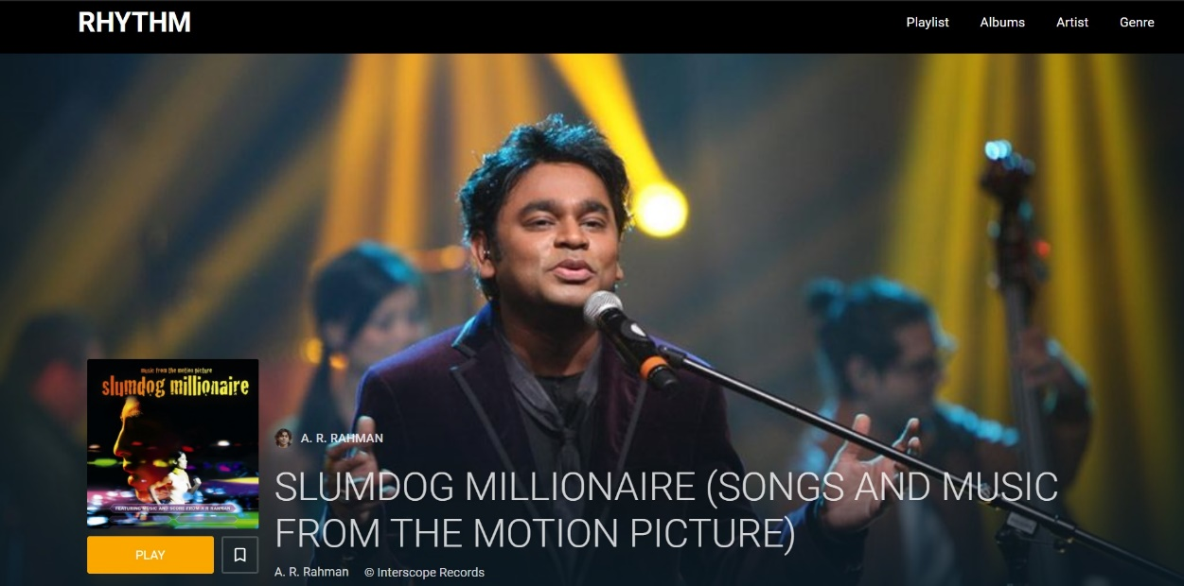

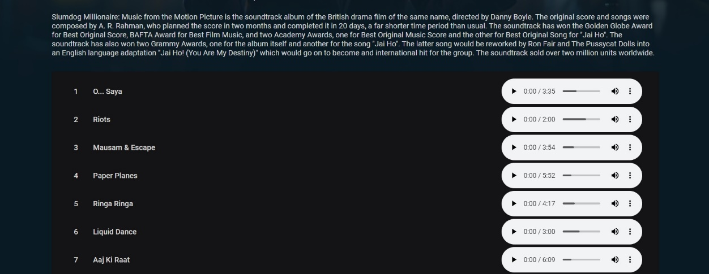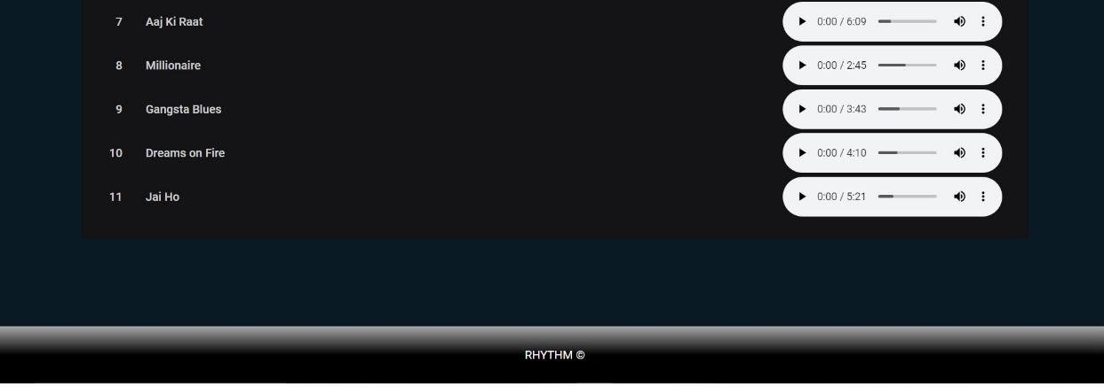

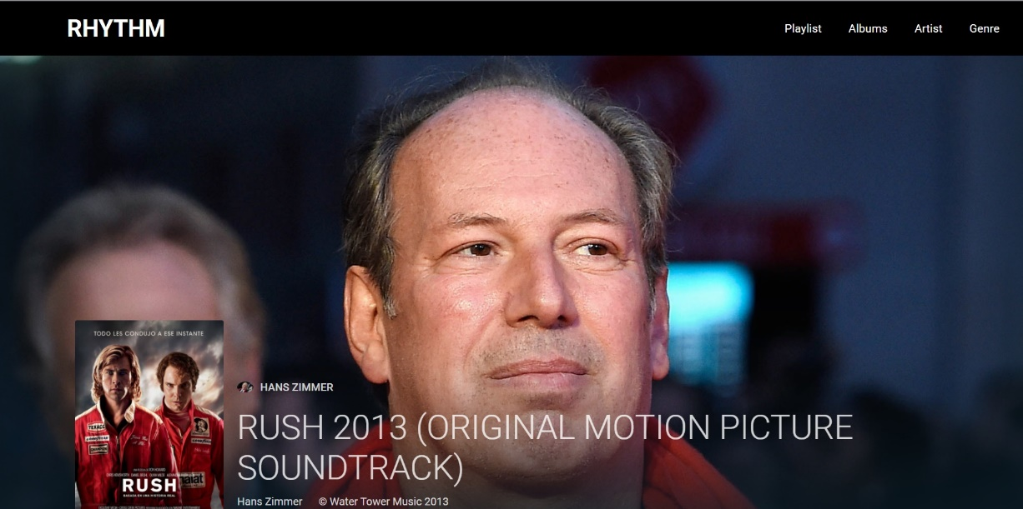

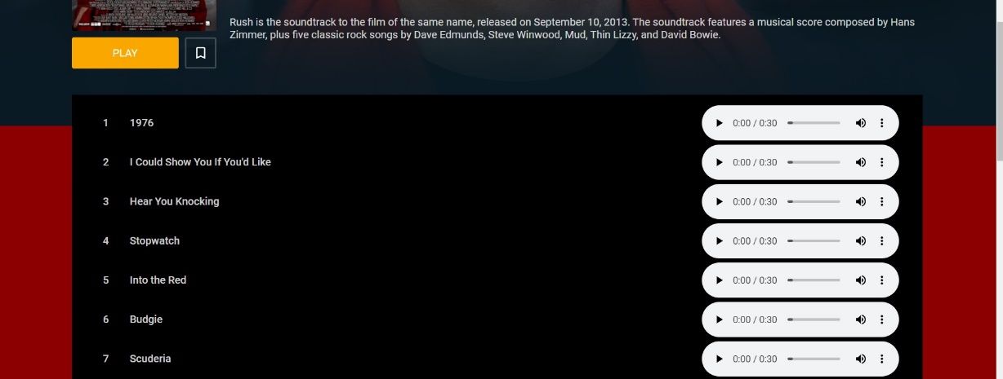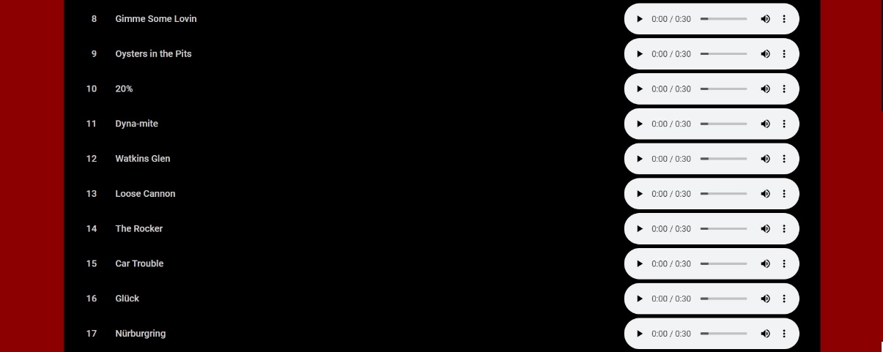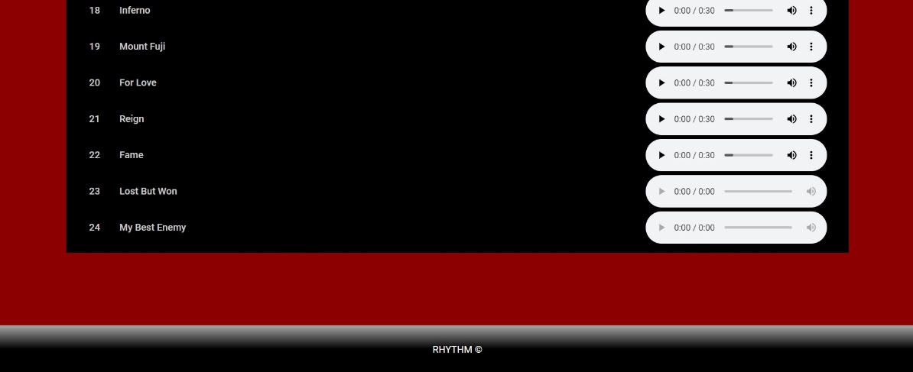

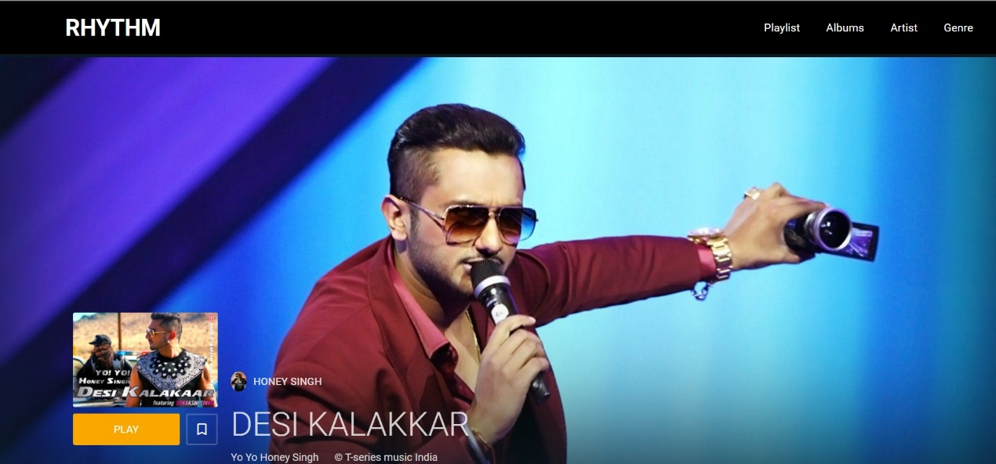

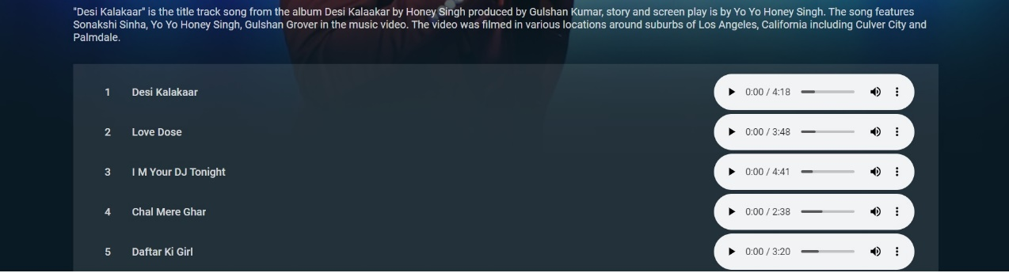

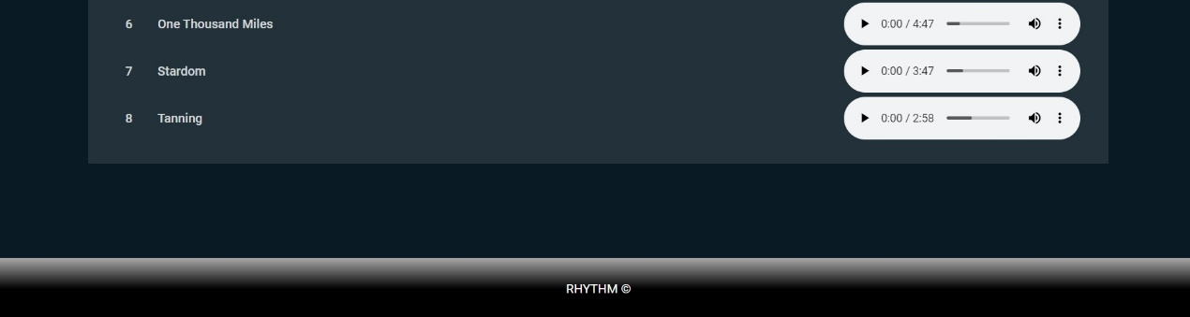

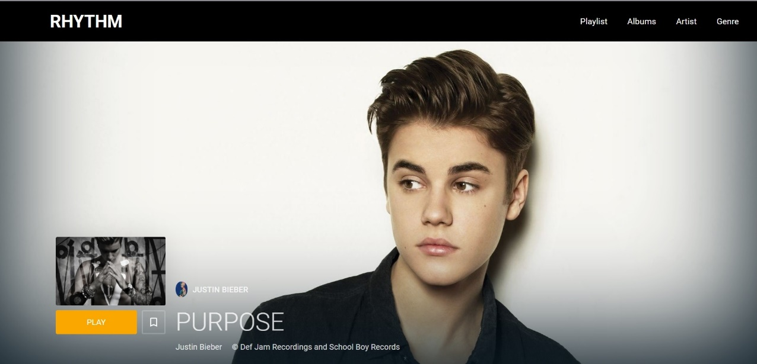

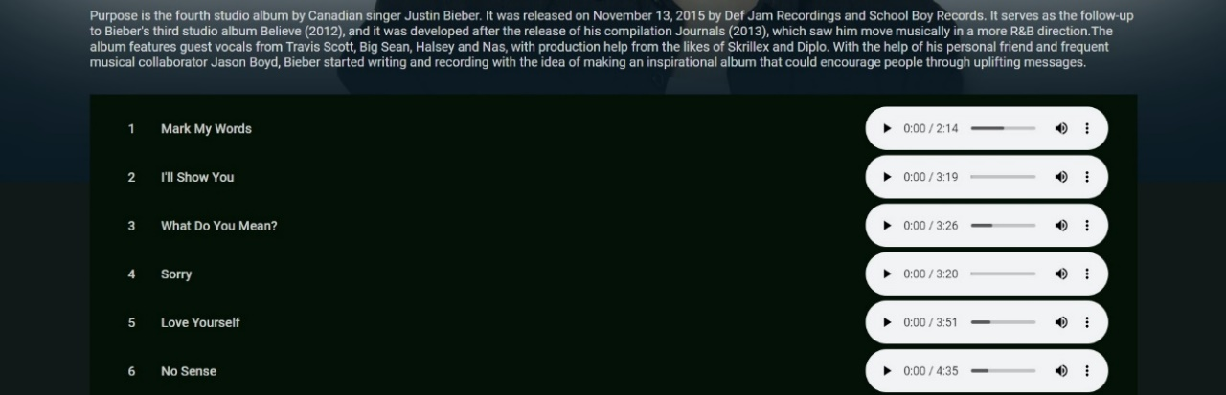

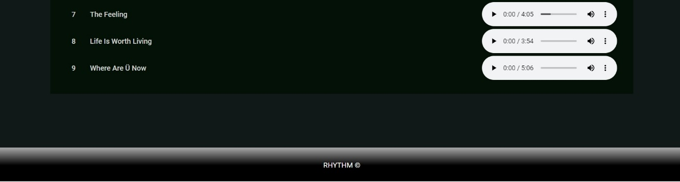

**CODE** (Same code is used for all the Artists page)

<html lang="en" >

<head>

<meta charset="utf-8">

<meta name="viewport" content="width=device-width, initial-scale=1.0">

<link rel="stylesheet" href="style.css">

<script src="https://kit.fontawesome.com/a076d05399.js"></script>

<style type="text/css">

*{

padding: 0;

margin: 0;

text-decoration: none;

list-style: none;

box-sizing: border-box;

}nav{

background: black;

height: 80px;

width: 100%;

}

label.logo{

color: white;

font-size: 35px;

line-height: 80px;

padding: 0 100px;

font-weight: bold;

}

nav ul{

float: right;

margin-right: 20px;

}

nav ul li{

display: inline-block;

line-height: 80px;

margin: 0 5px;

}

nav ul li a{

color: white;

font-size: 17px;

padding: 7px 13px;

border-radius: 3px;

}

a.active,a:hover{

background: transparent ;

font-size: 20px;

transition: .5s;

color: solid white;

}

.checkbtn{

font-size: 30px;

color: white;

float: right;

line-height: 80px;

margin-right: 40px;

cursor: pointer;

display: none;

}

#check{

display: none;

}

@media (max-width: 952px){

label.logo{

font-size: 30px;

padding-left: 50px;

}

nav ul li a{

font-size: 16px;

}

}

@media (max-width: 858px){

.checkbtn{

display: block;

}

ul{

position: fixed;

width: 100%;

height: 100vh;

background: orange;

top: 80px;

left: -100%;

text-align: center;

transition: all .5s;

}

nav ul li{

display: block;

margin: 50px 0;

line-height: 30px;

}

nav ul li a{

font-size: 20px;

}

a:hover,a.active{

background: none;

color: transparent;

}

#check:checked ~ ul{

left: 0;

}

}

</style>

</head>

<head>

<title>The Chainsmokers Available Albums</title>

<style>

@import url("https://fonts.googleapis.com/css?family=Roboto:300,400,500,700");

:root {

--color: #faa700;

--color-light: #f5ede1;

--dark: #a7a7a7;

--dark: #8a8a8a;

--darker: #303030;

--sans-serif: 'Roboto', sans-serif;

}

body {

font-family: var(--sans-serif);

background: #eeeeee;

}

body {

background: darkblue 80%;

}

.background {

width: 100%;

height: 56.25vw;

background: url(https://wallpapercave.com/wp/wp1874762.jpg) center/cover;

box-shadow: inset 0px -17vw 20vw 1vw #0a1a24;

position: absolute;

top: 0;

z-index: -1;

}

.background img {

max-width: 100%;

max-height: 100vh;

box-shadow: inset 0px -17vw 30vw 1vw #131313;

}

.background + section {

margin-top: 60vmin;

background: transparent;

--dark: rgba(white, .5);

--dark: rgba(white, .6);

--darker: rgba(white, .8);

}

.background + section .bookmark {

border-color: rgba(255, 255, 255, 0.2);

}

.background + section .bookmark svg {

fill: #fff;

}

.background + section .album-tracks {

background: #ECC209;

border: none;

}

section {

background: #fafafa;

margin: 100px 56px;

padding: 20px 56px;

color: var(--darker);

color: rgba(255, 255, 255, 0.8);

}

section .album-info:after {

content: " ";

display: block;

height: 0;

clear: both;

}

section .album-art {

float: left;

width: 220px;

margin-right: 20px;

margin-bottom: 20px;

}

section .album-art * {

border-radius: 3px;

}

section .album-art img {

width: 100%;

margin-bottom: 10px;

margin-top: -80px;

box-shadow: 0 5px 60px -3px rgba(0, 0, 0, 0.18);

}

section .play {

display: -webkit-box;

display: flex;

flex-wrap: initial;

-webkit-box-pack: center;

justify-content: center;

-webkit-box-align: center;

align-items: center;

align-content: initial;

color: white;

background: var(--color);

padding: 10px;

text-transform: uppercase;

-webkit-box-flex: 1;

flex: 1 0 50%;

}

section .bookmark {

display: -webkit-box;

display: flex;

flex-wrap: initial;

-webkit-box-pack: center;

justify-content: center;

-webkit-box-align: center;

align-items: center;

align-content: initial;

width: 48px;

height: 48px;

border: 3px solid var(--color-light);

margin-left: 10px;

}

section .album-details > * {

padding: 10px 0;

}

section h2 {

display: -webkit-box;

display: flex;

flex-wrap: initial;

-webkit-box-pack: initial;

justify-content: initial;

-webkit-box-align: center;

align-items: center;

align-content: initial;

color: var(--dark);

font-size: 16px;

font-weight: 500;

text-transform: uppercase;

}

section h2 img {

width: 24px;

border-radius: 50%;

margin-right: 10px;

}

section h1 {

font-size: 50px;

font-weight: 300;

word-wrap: break-word;

}

section h1 + span {

color: var(--dark);

}

section h1 + span span:first-child {

padding-right: 20px;

}

section p {

margin-top: 15px;

}

section .album-tracks {

background: #f8f8f8;

border: 1px solid #efefef;

margin-top: 20px;

}

@media (max-width: 800px) {

section {

margin: 100px 36px 36px 36px;

}

}

@media (max-width: 700px) {

section .album-art {

width: 100%;

}

section .album-art img {

width: auto;

max-width: 100%;

margin: -100px auto 10px auto;

display: block;

}

section .album-details {

float: left;

max-width: 100%;

}

}

@media (max-width: 550px) {

section {

margin: 100px 20px 20px 20px;

padding: 20px 16px;

}

section ol {

padding: 16px;

}

}

ol {

list-style-type: none;

padding: 20px 36px;

font-weight: 500;

}

ol li {

counter-increment: number;

display: -webkit-box;

display: flex;

flex-wrap: initial;

-webkit-box-pack: justify;

justify-content: space-between;

-webkit-box-align: center;

align-items: center;

align-content: initial;

height: 45px;

color: var(--dark);

}

ol li span:not(:last-child) {

margin-right: 2em;

}

@media (max-width: 700px) {

ol li span:not(:last-child) {

margin-right: 1em;

}

}

ol li span:first-child {

white-space: nowrap;

text-overflow: ellipsis;

overflow: hidden;

color: var(--darker);

}

ol li span:first-child:before {

content: counter(number);

margin-right: 2em;

color: var(--dark);

display: inline-block;

text-align: end;

width: 20px;

}

.actions {

display: -webkit-box;

display: flex;

flex-wrap: initial;

-webkit-box-pack: initial;

justify-content: initial;

-webkit-box-align: initial;

align-items: initial;

align-content: initial;

-webkit-box-flex: 1;

flex: 1 1 100%;

}

.footer {

left: 0;

margin-top: 10px;

width: 100%;

background: linear-gradient(to bottom, darkgrey 0%, black 50%);

color: white;

text-align: center;

position: bottom;

padding: 30px;

}

</style>

</head>

<body>

<nav>

<input type="checkbox" id="check">

<label for="check" class="checkbtn">

<i class="fas fa-bars"></i>

</label>

<label class="logo">RHYTHM</label>

<ul>

<li><a href="#">Playlist</a></li>

<li><a href="#">Albums</a></li>

<li><a href="#">Artist</a></li>

<li><a href="#">Genre</a></li>

</ul>

</nav>

</body>

<body translate="no" >

<div class="background"></div>

<section>

<div class="album-info">

<div class="album-art"><img src="https://images-na.ssl-images-amazon.com/images/I/91F8M-GRc9L._SY355_.jpg"/>

<div class="actions">

<div class="play">Play</div>

<div class="bookmark">

<svg xmlns="http://www.w3.org/2000/svg" fill="#faa800" height="24" viewbox="0 0 24 24" width="24">

<path d="M17 3H7c-1.1 0-1.99.9-1.99 2L5 21l7-3 7 3V5c0-1.1-.9-2-2-2zm0 15l-5-2.18L7 18V5h10v13z"></path>

<path d="M0 0h24v24H0z" fill="none"></path>

</svg>

</div>

</div>

</div>

<div class="album-details">

<h2> <img src="https://media.gettyimages.com/photos/alex-pall-and-andrew-taggart-of-the-chainsmokers-attend-kiss-108s-picture-id1068519110?s=2048x2048"/>The chainsmokers</h2>

<h1>COLLAGE</h1><span> <span>The Chainsmokers </span><span>&copy; Disruptor and Columbia Records</span></span>

<p>Collage is the second extended play (EP) by American DJ duo The Chainsmokers. It was released on November 4, 2016, through Disruptor Records and Columbia Records.</p>

</div>

</div>

<div class="album-tracks">

<ol>

<li> <span>Setting Fires</span><span><audio class="audio" controls="controls">

<source type="audio/mpeg" src="https://data.mymp3app.com/320/the-chainsmokers-xylo-setting-fires-lyric.mp3">

</audio></span></li>

<p> </P>

<li> <span>All We Know</span><span><audio class="audio" controls="controls">

<source type="audio/mpeg" src="https://data.mymp3app.com/320/the-chainsmokers-all-we-know-ft.-phoebe-ryan-jaydon-lewis-ngo-remix.mp3">

</audio></span></li>

<p> </P>

<li> <span>Closer</span><span><audio class="audio" controls="controls">

<source type="audio/mpeg" src="https://data.mymp3app.com/320/the-chainsmokers-closer-ft.-halsey-lyric.mp3">

</audio></span></li>

<p> </P>

<li> <span>Inside Out</span><span><audio class="audio" controls="controls">

<source type="audio/mpeg" src="https://allnaijaentertainment.com/wp-content/uploads/2018/10/The-Chainsmokers-Feat.-Charlee-Inside-Out-_-AllNaijaEntertainment.com_.mp3">

</audio></span></li>

<p> </P>

<li> <span>Don't Let Me Down</span><span><audio class="audio" controls="controls">

<source type="audio/mpeg" src="http://media.mtvpersian.net/2019/Oct/17/The%20Chainsmokers%20-%20Dont%20Let%20Me%20Down%20.mp3">

</audio></span></li>

</ol>

</div>

</section>

<div class="footer">

<h5class="monospace">RHYTHM &#169;</h5>

</div>

<script type="text/javascript">

window.addEventListener("play", function(evt)

{

if(window.$_currentlyPlaying && window.$_currentlyPlaying != evt.target)

{

window.$_currentlyPlaying.pause();

}

window.$_currentlyPlaying = evt.target;

}, true);

</script>

</body>

</html>

|  |  |
| --- | --- |
|  |  |
|  | **f.Genre Page**  Picture 1  Picture 3  **CODE**  <!DOCTYPE html>  <html> |
|  | <head> |
|  |  |
|  |  |
|  | <meta name="viewport" content="width=device-width, initial-scale=1.0"> |
|  | <link rel="stylesheet" href="style.css"> |
|  | <script src="<https://kit.fontawesome.com/a076d05399.js>"></script> |
|  | <style type="text/css"> |
|  | *{ |
|  | padding: 0; |
|  | margin: 0; |
|  | text-decoration: none; |
|  | list-style: none; |
|  | box-sizing: border-box; |
|  | } |
|  | body{ |
|  | font-family: Comic Sans MS; |
|  | background-image:url(https://images.pexels.com/photos/144429/pexels-photo-144429.jpeg?auto=compress&cs=tinysrgb&dpr=2&h=650&w=940); |
|  | } |
|  | nav{ |
|  | background: black; |
|  | height: 80px; |
|  | width: 100%; |
|  | } |
|  | label.logo{ |
|  | color: white; |
|  | font-size: 35px; |
|  | line-height: 80px; |
|  | padding: 0 100px; |
|  | font-weight: bold; |
|  | } |
|  | nav ul{ |
|  | float: right; |
|  | margin-right: 20px; |
|  | } |
|  | nav ul li{ |
|  | display: inline-block; |
|  | line-height: 80px; |
|  | margin: 0 5px; |
|  | } |
|  | nav ul li a{ |
|  | color: white; |
|  | font-size: 17px; |
|  | padding: 7px 13px; |
|  | border-radius: 3px; |
|  |  |
|  | } |
|  | a.active,a:hover{ |
|  | background: purple ; |
|  | font-size: 20px; |
|  | transition: .5s; |
|  | color: solid white; |
|  | } |
|  | .checkbtn{ |
|  | font-size: 30px; |
|  | color: white; |
|  | float: right; |
|  | line-height: 80px; |
|  | margin-right: 40px; |
|  | cursor: pointer; |
|  | display: none; |
|  | } |
|  | #check{ |
|  | display: none; |
|  | } |
|  | @media (max-width: 952px){ |
|  | label.logo{ |
|  | font-size: 30px; |
|  | padding-left: 50px; |
|  | } |
|  | nav ul li a{ |
|  | font-size: 16px; |
|  | } |
|  | } |
|  | @media (max-width: 858px){ |
|  | .checkbtn{ |
|  | display: block; |
|  | } |
|  | ul{ |
|  | position: fixed; |
|  | width: 100%; |
|  | height: 100vh; |
|  | background: orange; |
|  | top: 80px; |
|  | left: -100%; |
|  | text-align: center; |
|  | transition: all .5s; |
|  | } |
|  | nav ul li{ |
|  | display: block; |
|  | margin: 50px 0; |
|  | line-height: 30px; |
|  | } |
|  | nav ul li a{ |
|  | font-size: 20px; |
|  | } |
|  | a:hover,a.active{ |
|  | background: none; |
|  | color: transparent; |
|  | } |
|  | #check:checked ~ ul{ |
|  | left: 0; |
|  | } |
|  | } |
|  |  |
|  | </style> |
|  |  |
|  | </head> |
|  | <body> |
|  | <nav> |
|  | <input type="checkbox" id="check"> |
|  | <label for="check" class="checkbtn"> |
|  | <i class="fas fa-bars"></i> |
|  | </label> |
|  | <label class="logo">RHYTHM</label> |
|  | <ul> |
|  |  |
|  | <li><a href="#">Playlist</a></li> |
|  | <li><a class ="active" href="#">Albums</a></li> |
|  | <li><a href="#">Artist</a></li> |
|  | <li><a href="#">Genre</a></li> |
|  | </ul> |
|  | </nav> |
|  |  |
|  | </body> |
|  | </html> |
|  | <style> |
|  | img:hover{ |
|  |  |
|  |  |
|  | } |
|  |  |
|  | div.gallery { |
|  | border: 1px transparent; |
|  |  |
|  | } |
|  |  |
|  | div.gallery:hover { |
|  | border: 1px transparent; |
|  |  |
|  | } |
|  |  |
|  | div.gallery img { |
|  | width: 100%; |
|  | height: auto; |
|  |  |
|  | } |
|  | div.desc { |
|  | padding: 15px; |
|  | text-align: center; |
|  | color: white; |
|  |  |
|  | } |
|  | div.image:hover{ |
|  | transform: scaleX(-1); |
|  | } |
|  |  |
|  | * { |
|  | box-sizing: border-box; |
|  | border-radius: 8px; |
|  |  |
|  | } |
|  |  |
|  | .responsive { |
|  | padding: 0 6px; |
|  | float: left; |
|  | width: 24.99999%; |
|  |  |
|  | } |
|  | h2 |
|  | { |
|  | text-align: center; |
|  | background-color: rgba(0 2 5 66); |
|  |  |
|  | } |
|  |  |
|  | @media only screen and (max-width: 700px) { |
|  | .responsive { |
|  | width: 49.99999%; |
|  | margin: 6px 0; |
|  |  |
|  |  |
|  | } |
|  | } |
|  |  |
|  | @media only screen and (max-width: 500px) { |
|  | .responsive { |
|  | width: 100%; |
|  |  |
|  | } |
|  | } |
|  |  |
|  | .clearfix:after { |
|  | content: ""; |
|  | display: table; |
|  | clear: both; |
|  |  |
|  | } |
|  | </style> |
|  | </head> |
|  | <body> |
|  |  |
|  |  |
|  |  |
|  | <div class="responsive"> |
|  | <div class="gallery"> |
|  | <a target="_blank" href=""> |
|  | <div class="image"> |
|  | <img src="<https://m.hindustantimes.com/rf/image_size_960x540/HT/p2/2018/03/13/Pictures/concert-maestro-ilayaraja-enthralled-music-lovers-first_49150ca4-2677-11e8-9f95-06a811d7e716.jpg>" alt= "ilayaraja" width="600" height="auto"> |
|  | </a></div> |
|  | <div class="desc">Endrum ilayaraja</div> |
|  | </div> |
|  | </div> |
|  |  |
|  |  |
|  | <div class="responsive"> |
|  | <div class="gallery"> |
|  | <a target="_blank" href=""> |
|  | <div class="image"> |
|  | <img src="<https://tamil.stage3.in/root_upld/general-news/2018/01/ART045668436021407/org_71606201801231106.jpg>" alt= "yuvan s raja" width="800" height="auto"> |
|  | </a></div> |
|  | <div class="desc">U1</div> |
|  | </div> |
|  | </div> |
|  |  |
|  |  |
|  | <div class="responsive"> |
|  | <div class="gallery"> |
|  | <a target="_blank" href=""> |
|  | <div class="image"> |
|  | <img src="<https://images.indianexpress.com/2019/01/ar-rahman-top-tamil-songs-from-the-90s-1200.jpg>" alt= "A R rahman" width="600" height="auto"> |
|  | </a></div> |
|  | <div class="desc">A R R</div> |
|  | </div> |
|  | </div> |
|  |  |
|  | <div class="responsive"> |
|  | <div class="gallery"> |
|  | <a target="_blank" href=""> |
|  | <div class="image"> |
|  | <img src="<https://i.ytimg.com/vi/DwiEDAsWpJs/maxresdefault.jpg>" alt= "Hans Zimmer" width="600" height="auto"> |
|  | </a></div> |
|  | <div class="desc">Rush</div> |
|  | </div> |
|  | </div> |
|  |  |
|  |  |
|  | <div class="responsive"> |
|  | <div class="gallery"> |
|  | <a target="_blank" href=""> |
|  | <div class="image"> |
|  | <img src="<https://i.ytimg.com/vi/6Iovt3Pe0S4/maxresdefault.jpg>" alt= "honey singh" width="600" height="auto"> |
|  | </a></div> |
|  | <div class="desc">Desi Kalakaar</div> |
|  | </div> |
|  | </div> |
|  |  |
|  |  |
|  | <div class="responsive"> |
|  | <div class="gallery"> |
|  | <a target="_blank" href=""> |
|  | <div class="image"> |
|  | <img src="<https://www.kiss925.com/wp-content/uploads/sites/59/2019/12/selena-gomez-rare-1024x399-e1577046724182-1024x576.jpg>" |
|  | alt="Cinque Terre" width="600" height="auto" > |
|  | </a></div> |
|  | <div class="desc">Rare</div> |
|  | </div> |
|  | </div> |
|  |  |
|  | <div class="responsive"> |
|  | <div class="gallery"> |
|  | <a target="_blank" href=""> |
|  | <div class="image"> |
|  | <img src="<https://timesofindia.indiatimes.com/thumb/msid-65103169,width-1200,height-900,resizemode-4/.jpg>" alt="charlie puth" width="600" height="300"> |
|  | </a></div> |
|  | <div class="desc">Voice notes</div> |
|  | </div> |
|  | </div> |
|  |  |
|  | <div class="responsive"> |
|  | <div class="gallery"> |
|  | <a target="_blank" href=""> |
|  | <div class="image"> |
|  | <img src="<https://roundhouse-assets.s3.amazonaws.com/assets/Image/13275-fitandcrop-1200x681.jpg>" alt="Mountains" width="600" height="auto"> |
|  | </a></div> |
|  | <div class="desc">Evolve</div> |
|  | </div> |
|  | </div> |
|  |  |
|  | <div class="responsive"> |
|  | <div class="gallery"> |
|  | <a target="_blank" href=""> |
|  | <div class="image"> |
|  | <img src="<https://music.mxdwn.com/wp-content/uploads/2016/12/collage-e1481165261413-1280x720.jpg>" alt=" collage" width="600" height="auto"> |
|  | </a></div> |
|  | <div class="desc">Collage</div> |
|  | </div> |
|  | </div> |
|  |  |
|  | <div class="responsive"> |
|  | <div class="gallery"> |
|  | <a target="_blank" href=""> |
|  | <div class="image"> |
|  | <img src="<https://www.grammy.com/sites/com/files/styles/news_detail_header/public/news/r-7717555-1447497442-7892.jpeg.jpg?itok=zq_E8MV0>" alt="justin" width="600" height="auto"> |
|  | </a></div> |
|  | <div class="desc">Purpose</div> |
|  | </div> |
|  | </div> |
|  |  |
|  | <div class="responsive"> |
|  | <div class="gallery"> |
|  | <a target="_blank" href=""> |
|  | <div class="image"> |
|  | <img src="<https://www.pluggedin.com/wp-content/uploads/2020/01/Ariana__Thank_You_Next__Large.jpg>" alt="ariana" width="600" height="auto"> |
|  | </a></div> |
|  | <div class="desc">Thank you, next.</div> |
|  | </div> |
|  | </div> |
|  |  |
|  | <div class="responsive"> |
|  | <div class="gallery"> |
|  | <a target="_blank" href=""> |
|  | <div class="image"> |
|  | <img src="<https://www.pluggedin.com/wp-content/uploads/2020/01/Shawn_Mendes__Illuminate__Large.jpg-1024x587.jpeg>" alt="sm" width="600" height="auto"> |
|  | </a></div> |
|  | <div class="desc">Illuminate</div> |
|  | </div> |
|  | </div> |
|  |  |
|  |  |
|  | <div class="clearfix"></div> |
|  |  |
|  | </body> |
|  | </html> |

**7. FUTURE ENHANCEMENT OF THE WEBSITE**

There are future enhancements that will be done to the website. and maybe some other kind of future changes will be possible in our system also.

* Addition of more songs in different languages.
* Implementation of search engine.
* Implementation of more feature to make more user friendly.
* Implement video albums feature.
* The next version will also resolve any error or mistake remained unsolved in this version

**8. CONCLUSION**

We hereby, conclude our project by listing future enhancements and benefits.These are the future enhancements we are going to do in our project. If there is any other future requirement by the user for the enhancement of the system, then it is possible to implement them.

* Addition of more songs in different languages.
* Implementation of more feature to make more user friendly.
* Implement video albums feature.

The next version will also resolve any error or mistake that remained unsolved in this version. People perfect more User friendly with a large collection of Music websites to listen to music. A lot of such websites are around but not every website is free of cost unlike us.

**9. BIBLOGRAPHY**

* Website Referred

1. [www.w3schools.com](http://www.w3schools.com)
2. [www.tutorialpoint/css.com](http://www.tutorialpoint/css.com)
3. [www.freefrontend/css.com](http://www.freefrontend/css.com)

* Text Books Referred

1. HTML & CSS:Design and Build Web Sites by Jon Duckett

**Personal Details Of Project Members**

|  |  |
| --- | --- |
| Student Name | Ancima T Manoj |
| Register Number | 18MEC24009 |
| Mail id | anci.manoj3@gmail.com |
| Contact number | 9035729050 |

|  |  |
| --- | --- |
| Student Name | Nisha Sangavi V |
| Register Number | 18MEC24007 |
| Mail id | nishaangelic492000@gmail.com |
| Contact Number | 7090079048 |

|  |  |
| --- | --- |
| Student Name | George Louis |
| Register Number | 18MEC24003 |
| Mail id | georgelouis543@gmail.com |
| Contact Number | 8197104320 |

|  |  |
| --- | --- |
| Student Name | Shariba thasneem |
| Register Number | 18MEC24030 |
| Mail id | sharibathasneem@gmail.com |
| Contact Number | 9731310985 |